
CSE471: System Analysis and Design
Project Report
Project Title: Smart Local Service Intelligence Platform
Group No: 07, CSE471 Lab Section: 12
Summer 2025
ID | Name
23101162 | Deema Tabassum Khan
23101214 | Farhan Shahriar
20101234 | Shees Mohammad Hossain Saud

Submission Date:
Table of Contents
1. System Request.................................................................................................................................... 3 Business need:................................................................................................................................... 3 Business requirements:......................................................................................................................3 Business value:.................................................................................................................................. 3 Special issues or constraints:............................................................................................................. 3
2. Functional Requirements..................................................................................................................... 3 3. Technology (Framework, Languages)................................................................................................. 3 4. Backend Development......................................................................................................................... 3 5. User Interface Design...........................................................................................................................3 6. Frontend Development.........................................................................................................................3 7. User Manual.........................................................................................................................................3 8. Performance and Network Analysis.....................................................................................................3 9. Github Repo [Public] Link...................................................................................................................4 10. Link of Deployed Project...................................................................................................................4 11. Individual Contribution......................................................................................................................4 12. References..........................................................................................................................................5
2
1. System Request

Business Need:
The Smart Local Service Intelligence Platform is designed to connect customers with local service providers in a reliable and efficient manner. Existing service platforms often suffer from issues such as lack of transparency in pricing, poor service tracking, limited communication, and inefficient dispute handling.
This system aims to provide a centralized solution where users can search for services, book workers, monitor service progress, and manage post-service activities such as cost verification, warranty tracking, and dispute resolution. The platform improves overall user experience by ensuring transparency, accountability, and streamlined service management.

Business Requirements:
Using the Smart Local Service Intelligence Platform, users, service providers, and administrators will be able to interact through a unified system. The key functionalities include:
- Allow users to browse, search, and select local service providers based on category and availability
- Enable users to book services and track service status in real-time
- Provide a dashboard for users to manage bookings, history, and service details
- Allow workers/service providers to manage assigned jobs and update service progress
- Implement real-time cost estimation with a transparent breakdown (labor, parts, urgency charges)
- Display itemized cost details before confirming bookings
- Track and manage warranty duration for completed services
- Enable customers to submit disputes with supporting documents
- Provide an admin-controlled dispute resolution workflow
- Allow users to flag specific cost components for review
- Provide secure file upload functionality for dispute attachments
- Enable real-time dispute tracking and status updates
- Implement authentication and role-based access control for users, workers, and admins

Business Value:
We expect that the Smart Local Service Intelligence Platform will enhance the efficiency and reliability of local service management. By integrating booking, tracking, cost transparency, and dispute resolution into a single platform, the system significantly improves user convenience and trust.
Transparent pricing and cost breakdowns reduce uncertainty and increase customer confidence. Warranty tracking and structured dispute handling ensure accountability and service quality. The platform also benefits service providers by offering better job management and visibility.
Over time, the system will generate valuable insights from user interactions, cost patterns, and dispute data, enabling continuous improvement. Its user-friendly design and comprehensive features will help attract a wide user base, giving it a strong competitive advantage in the service marketplace.

Special Issues or Constraints:
- Ensuring accuracy and consistency in real-time cost estimation across different service types
- Managing secure file uploads and storage for dispute-related documents
- Implementing strong authentication and role-based access control
- Maintaining data privacy and protection for user information
- Handling concurrent users, bookings, and dispute requests efficiently
- Ensuring system scalability as the number of users and services increases
- Designing a simple and user-friendly interface despite complex functionalities
- Preventing duplicate disputes or incorrect cost flagging through validation logic
2. Functional Requirements

Module 1 [Saud]
- The system allows users to submit issues using natural language text input.
- The system automatically categorizes issues into predefined categories such as Electrical, Plumbing, and AC-related problems.
- The system provides a guided troubleshooting flow using a step-by-step decision-making process.
- The system evaluates and displays a risk level indicator (Low / Medium / High) before suggesting any DIY action.
- The system analyzes the submitted issue based on category, complexity, and risk level to determine whether it is suitable for DIY resolution.
- The system generates an intelligent recommendation indicating whether the user should proceed with DIY troubleshooting or seek professional assistance.
- The system calculates and displays a confidence score (%) representing the likelihood of successful DIY resolution.
- The system maintains a record of all user-submitted issues, including problem description, issue category, suggested troubleshooting steps, risk level, and final outcome.
- The system stores troubleshooting history to improve future recommendations and provide users access to past issue resolutions.

Module 2[Farhan]
- The system maintains worker profiles including skill details, ratings, experience, and service area. [The system allows workers to update their real-time availability status.
- The system ranks workers using a rating-based ranking algorithm.
- The system allows users to send service requests to workers.
- The system supports an emergency priority request option for urgent service needs.
- The system allows users to rate and review after service completion.
- The system filters workers based on the user’s location.
- The system allows payment method for customer to pay workers
- The system allows message functionalities to customer and workers
- The system allows customers to post jobs and hire workers according to their needs.

Module 3[Deema]
- The system provides an estimated service cost before booking.
- The system displays a transparent cost breakdown including labor, parts, and urgency charges.
- The system tracks service warranty duration for completed jobs.
- The system allows users to submit disputes regarding service quality or pricing.
- The system provides a workflow for dispute resolution managed by the admin.

3. Technology (Framework, Languages)
● Frontend: React.js
● Backend: Node.js, Express.js
● Database: MongoDB
● Authentication: JWT (JSON Web Token)
● Deployment: Vercel (Frontend), Render / Railway (Backend)
● Architecture: MERN Stack

4. Backend Development
Attach at least 5 code snippets of Backend/API development with proper description. Also, attach corresponding screenshots of Postman API testing.
API-1: [Deema]
const express = require("express");
const router = express.Router();
const Cost = require("../models/Cost");

// GET all costs - Retrieve complete cost breakdown for all services
router.get("/", async (req, res) => {
try {
const costs = await Cost.find();
res.json(costs);
} catch (error) {
res.status(500).json({ error: error.message });
}
});
module.exports = router;
This endpoint retrieves all service costs from the database with complete itemized breakdown. It displays labor costs, parts costs, and urgency charges separately so customers can understand the cost structure before booking. The endpoint is called when the user navigates to the cost estimation page and returns all available service costs with their current flag status.
API-2: [Deema]
// POST - Create warranty after service completion
router.post("/", async (req, res) => {
try {
const { jobId, warrantyDuration, startDate, terms, serviceType } = req.body;
if (!jobId || !warrantyDuration) {
return res.status(400).json({ message: "jobId and warrantyDuration are required" });
}
// Calculate expiry date
const expiryDate = new Date(startDate);
expiryDate.setMonth(expiryDate.getMonth() + warrantyDuration);
const warranty = new Warranty({
jobId,
serviceType,
startDate,
warrantyDuration,
expiryDate,
terms,
status:"Active",
coverage: {
labor: true,
parts: true,
emergency_service: true
},
claimsRemaining: 3
});
await warranty save();
res.status(201).json(warranty);
} catch (error) {
res.status(500).json({ error: error.message });
}
});
module.exports = router;

This endpoint creates a warranty record after service completion. It calculates the warranty expiry date based on duration provided and stores all warranty details including service type, coverage terms, and coverage scope. The warranty is automatically set to "Active" status and remains accessible to customers to verify coverage details and check if their service is still under warranty protection.
API-3: [Deema]
// POST - Submit dispute with file attachments
router.post("/", upload.array("attachments", 5), async (req, res) => {
try {
const { jobId, disputeType, subject, description } = req.body;

if (!jobId || !subject) {
return res.status(400).json({ message: "jobId and subject are required" });
}
// Process uploaded files
const attachments = req.files.map(file => ({
filename: file.originalname,
path: `/uploads/disputes/${file.filename}`,
size: file.size
}));
const dispute = new Dispute({
jobId,
disputeType,
subject,
description,
status: "Submitted",
attachments,
attachmentCount: attachments.length,
createdAt: new Date()
});
await dispute.save();
res.status(201).json(dispute);
} catch (error) {
res.status(500).json({ error: error.message });
}
});
module.exports = router;
This endpoint enables users to submit disputes regarding service quality or pricing with support for multiple file attachments. It uses multipart/form-data to handle file uploads where users can attach photos, receipts, invoices, or other evidence. The endpoint stores dispute metadata, file paths, attachment count, and submission timestamp. Admin can later access these files to investigate and make informed resolution decisions.
API-4: [Deema]
// PUT - Update dispute status (Admin only)
router.put("/:id/status", async (req, res) => {
try {
const { id } = req.params;
const { status, resolution, compensationAmount, notes } = req.body;

if (!status || !resolution) {
return res.status(400).json({ message: "status and resolution are required" });
}
const dispute = await Dispute.findByIdAndUpdate(
id,
{
status,
resolution,
compensationAmount: compensationAmount || 0,
notes,
resolvedAt: new Date(),
resolvedBy: "admin_user_001" // Get from authenticated admin
},
{ new: true }
);
if (!dispute) {
return res.status(404).json({ message: "Dispute not found" });
}
res.json(dispute);
} catch (error) {
res.status(500).json({ error: error.message });
}
});
module.exports = router;
This is an admin-only endpoint that resolves disputes by updating the dispute status with investigation findings and compensation decisions. Admin provides resolution details explaining whether the dispute is approved, rejected, or partially approved, along with compensation amount if applicable. The endpoint records admin user details and resolution timestamp so customers can view the final decision and receive compensation accordingly.
API-5: [Deema]
// GET - Get warranty by specific job ID
router.get("/:jobId", async (req, res) => {
try {
const { jobId } = req.params;
const warranty = await Warranty.findOne({ jobId });
if (!warranty) {
return res.status(404).json({ message: "Warranty not found for this job" });
}
res.json(warranty);
} catch (error) {
res.status(500).json({ error: error.message });
}
});
module.exports = router;
This endpoint retrieves warranty information for a specific completed job. It's called when displaying warranty details on the service details page or warranty card. The endpoint returns warranty expiry date, coverage details, remaining claims, and active status so customers can verify if their job is still under warranty protection and check coverage scope.
https://drive.google.com/file/d/1azo12CURuJvInsaeK8ybw2mugnfXR8Lc/view?usp=sharing

API-1:[FARHAN]-Worker Profile Management Endpoint:
This endpoint allows workers to create and update their complete profile including skill details, experience, service area, and availability status. The profile stores worker information like name, qualifications, certifications, years of experience, and the geographical area they serve. This data is essential for the worker ranking algorithm and location-based filtering system.
// POST - Create/Update Worker Profile
router.post("/profile", async (req, res) => {
try {
const {
userId,
name,
skills,
experience,
serviceArea,
hourlyRate,
bio,
certifications,
availability
} = req.body;

if (!userId || !name || !skills || !serviceArea) {
return res.status(400).json({
message: "userId, name, skills, and serviceArea are required"
});
}
let worker = await Worker.findOne({ userId });

if (worker) {
// Update existing profile
worker = await Worker.findByIdAndUpdate(
worker._id,
{
name,
skills,
experience,
serviceArea,
hourlyRate,
bio,
certifications,
availability,
updatedAt: new Date()
},
{ new: true }
);
} else {
// Create new profile
worker = new Worker({
userId,
name,
skills,
experience,
serviceArea,
hourlyRate,
bio,
certifications,
availability: availability || "available",
rating: 5.0,
totalReviews: 0,
totalJobs: 0
});
await worker.save();
}
res.status(201).json({
message: "Worker profile saved successfully",
worker
});
} catch (error) {
res.status(500).json({ error: error.message });
}
});
// GET - Get Worker Profile by ID
router.get("/profile/:workerId", async (req, res) => {
try {
const { workerId } = req.params;
const worker = await Worker.findById(workerId);
if (!worker) {
return res.status(404).json({ message: "Worker not found" });
}
res.json(worker);
} catch (error) {
res.status(500).json({ error: error.message });
}
});
module.exports = router;
API-2:[FARHAN]-Update Worker Availability Status Endpoint:
This endpoint allows workers to update their real-time availability status (available, busy, offline). The availability status is crucial for the system to show customers which workers are currently able to accept new service requests. The endpoint updates the worker's availability and last updated timestamp for tracking when they last changed their status.
// PATCH - Update Worker Availability Status
router.patch("/availability/:workerId", async (req, res) => {
try {
const { workerId } = req.params;
const { availability } = req.body;
const validStatuses = ["available", "busy", "offline"];
if (!validStatuses.includes(availability)) {
return res.status(400).json({
message: "Invalid availability status. Must be: available, busy, or offline"
});
}
const worker = await Worker.findByIdAndUpdate(
workerId,
{
availability,
lastAvailabilityUpdate: new Date()
},
{ new: true }
);

if (!worker) {
return res.status(404).json({ message: "Worker not found" });
}
res.json({
message: `Availability updated to ${availability}`,
worker: {
_id: worker._id,
name: worker.name,
availability: worker.availability,
lastAvailabilityUpdate: worker.lastAvailabilityUpdate
}
});
} catch (error) {
res.status(500).json({ error: error.message });
}
});
module.exports = router;

API-3[FARHAN]-Customer Worker message option:
This endpoint helps customer and workers to communicate with each other enabling message option.external api socket.io was implemented.
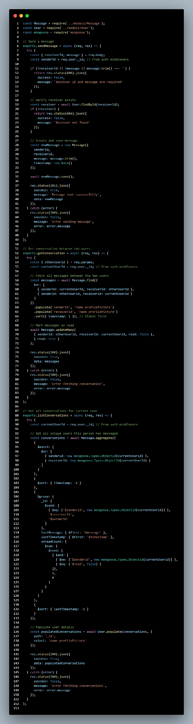

API-4:[FARHAN]-Service Request Management Endpoint:
This endpoint allows customers to send service requests to workers, including standard and emergency priority options. When a customer submits a request, the system stores request details (service type, urgency, description, location) and notifies the worker. The endpoint supports emergency priority requests that are flagged for urgent handling and prioritized in the worker's queue.
// POST - Create Service Request
router.post("/", async (req, res) => {
try {
const {
customerId,
workerId,
serviceType,
description,
location,
preferredDateTime,
priority,
estimatedDuration
} = req.body;
if (!customerId || !workerId || !serviceType || !location) {
return res.status(400).json({
message: "customerId, workerId, serviceType, and location are required"
});
}
const validPriorities = ["normal", "emergency"];
if (priority && !validPriorities.includes(priority)) {
return res.status(400).json({
message: "Priority must be 'normal' or 'emergency'"
});
}
const serviceRequest = new ServiceRequest({
customerId,
workerId,
serviceType,
description,
location,
preferredDateTime,
priority: priority || "normal",
estimatedDuration,
status: "pending",
createdAt: new Date()
});

await serviceRequest.save();

// Update worker's total requests
await Worker.findByIdAndUpdate(
workerId,
{ $inc: { pendingRequests: 1 } }
);
res.status(201).json({
message: "Service request created successfully",
request: serviceRequest
});
} catch (error) {
res.status(500).json({ error: error.message });
}
});
// GET - Get All Service Requests for a Worker
router.get("/worker/:workerId", async (req, res) => {
try {
const { workerId } = req.params;
const { status } = req.query;
let filter = { workerId };
if (status) {
filter.status = status;
}
const requests = await ServiceRequest.find(filter)
.sort({ createdAt: -1 })
.lean();

res.json({
totalRequests: requests.length,
requests
});
} catch (error) {
res.status(500).json({ error: error.message });
}
});
// PATCH - Update Request Status
router.patch("/:requestId/status", async (req, res) => {
try {
const { requestId } = req.params;
const { status } = req.body;

const validStatuses = ["pending", "accepted", "completed", "cancelled"];
if (!validStatuses.includes(status)) {
return res.status(400).json({
message: "Invalid status"
});
}
const request = await ServiceRequest.findByIdAndUpdate(
requestId,
{ status, updatedAt: new Date() },
{ new: true }
);
if (!request) {
return res.status(404).json({ message: "Request not found" });
}
res.json({
message: `Request status updated to ${status}`,
request
});
} catch (error) {
res.status(500).json({ error: error.message });
}
});
module.exports = router

API-5:[FARHAN]-Worker Ranking Algorithm Endpoint:
This endpoint retrieves the top-ranked workers based on a ranking algorithm that considers multiple factors: overall rating, number of reviews (experience), total jobs completed, and response time. The algorithm gives higher weight to workers with more reviews and completed jobs, ensuring that established, reliable workers rank higher. This endpoint powers the "Best Workers" or "Top Rated" listings.
// GET - Get Top Ranked Workers
router.get("/ranked/top", async (req, res) => {
try {
const { limit = 10, skill, city } = req.query;
let filter = { availability: { $ne: "offline" } };
if (skill) {
filter.skills = { $in: [skill] };
}
if (city) {
filter["serviceArea.city"] = city;
}
const workers = await Worker.find(filter)
.select("_id name skills rating totalReviews totalJobs hourlyRate serviceArea availability")
.lean();
// Calculate ranking score for each worker
const rankedWorkers = workers
.map((worker) => {
const ratingScore = (worker.rating / 5) * 0.4;
const reviewScore = Math.min(worker.totalReviews / 100, 1) * 0.3;
const jobsScore = Math.min(worker.totalJobs / 200, 1) * 0.2;
const availabilityScore = (worker.availability === "available" ? 1 : 0.5) * 0.1;

const rankingScore = (
ratingScore +
reviewScore +
jobsScore +
availabilityScore
) * 100;
return {
...worker,
rankingScore: parseFloat(rankingScore.toFixed(2))
};
})
.sort((a, b) => b.rankingScore - a.rankingScore)
.slice(0, parseInt(limit));

res.json({
totalWorkers: rankedWorkers.length,
workers: rankedWorkers
});
} catch (error) {
res.status(500).json({ error: error.message });
}
});
module.exports = router;
_Assignment 03 API Postman Collection.docx (2).pdf

[Saud]
Shees_mohammad_hossain_saud_section_12_ Assignment 03 API Postman Collection cse471.docx (1).pdf
API_1: api for ai start session 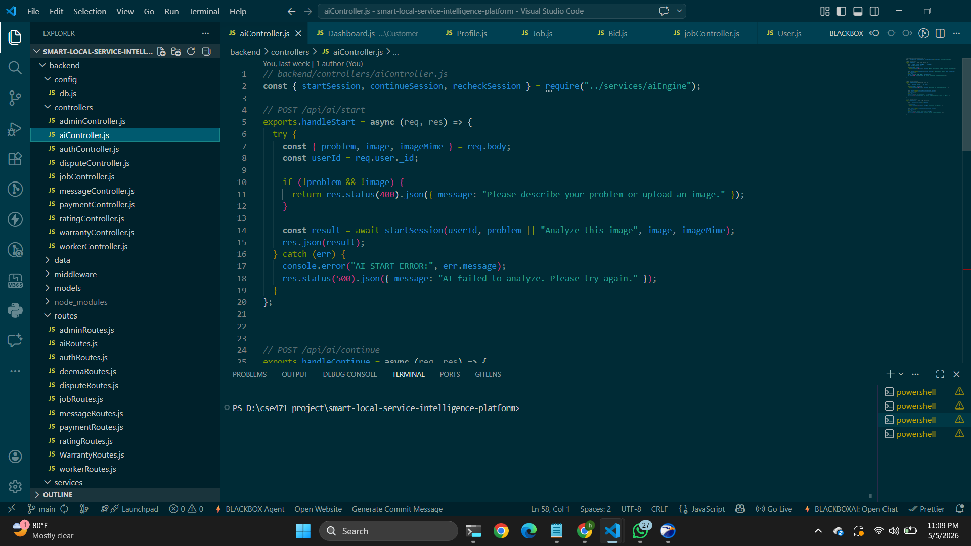
Api -2 [saud] continue a ai session 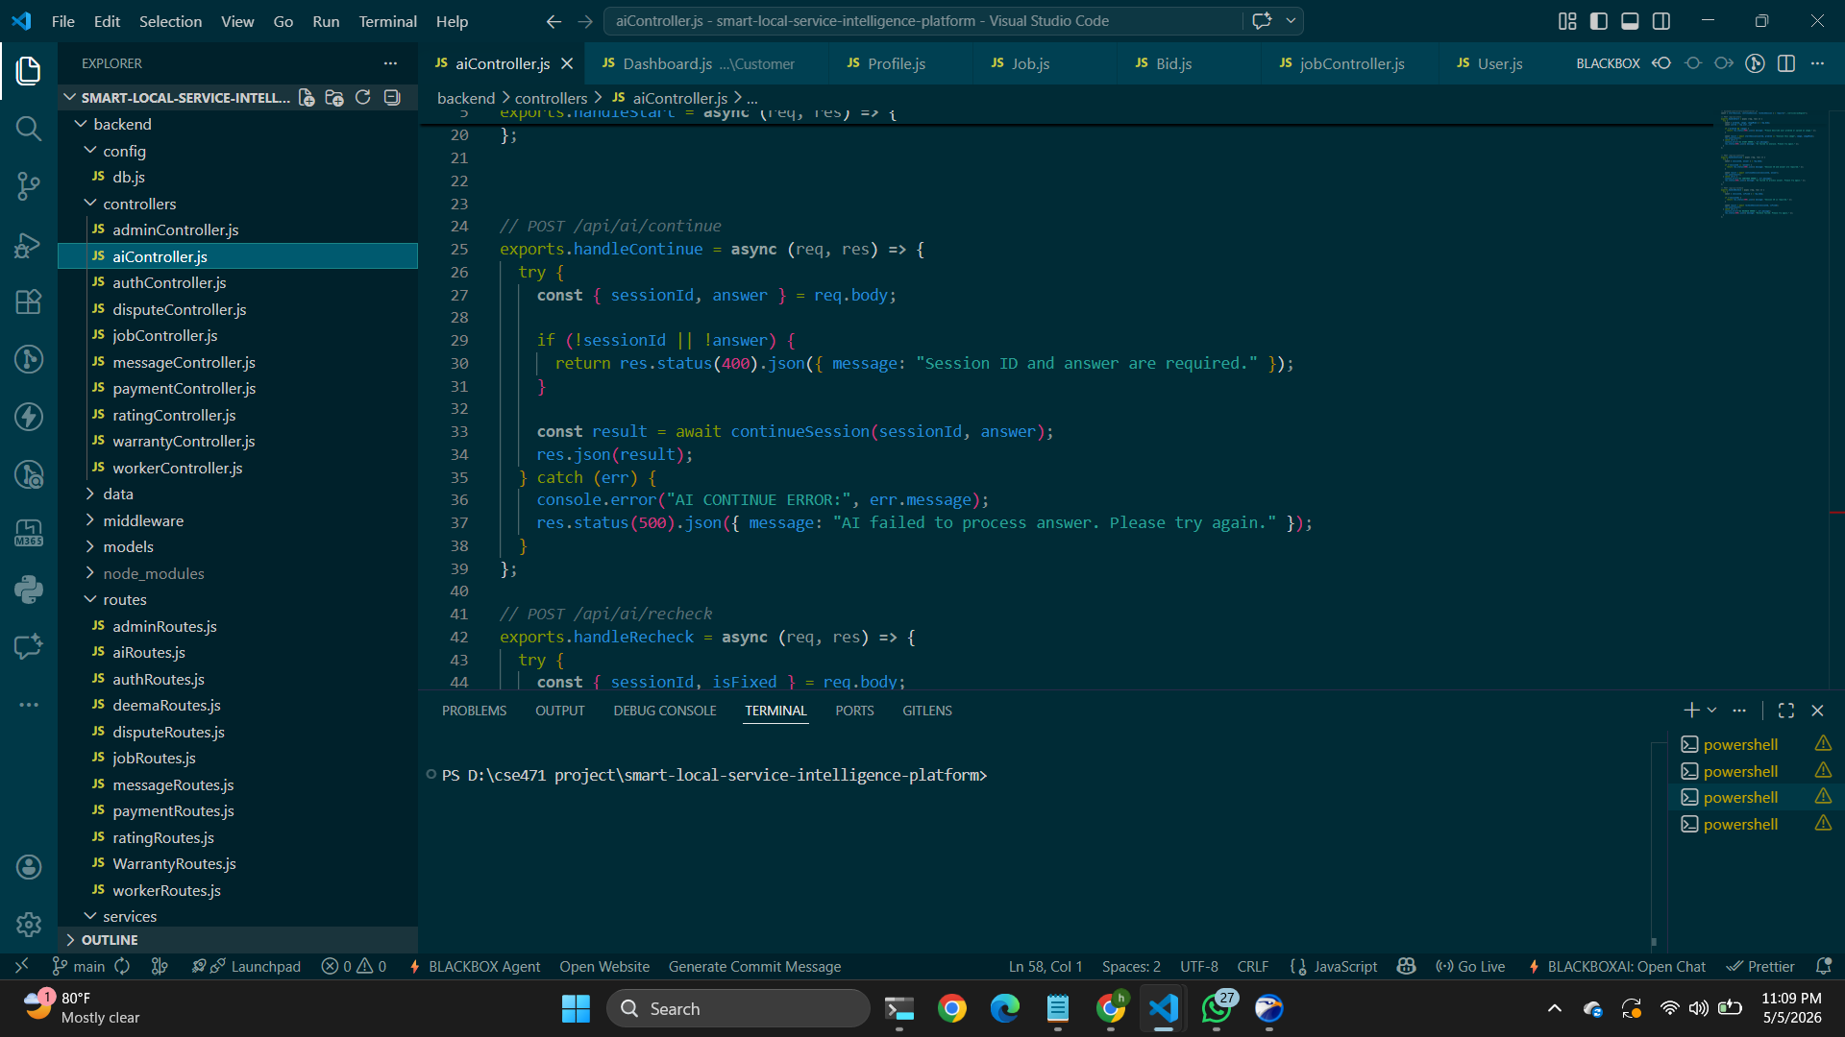
Api-3[saud] - recheck session

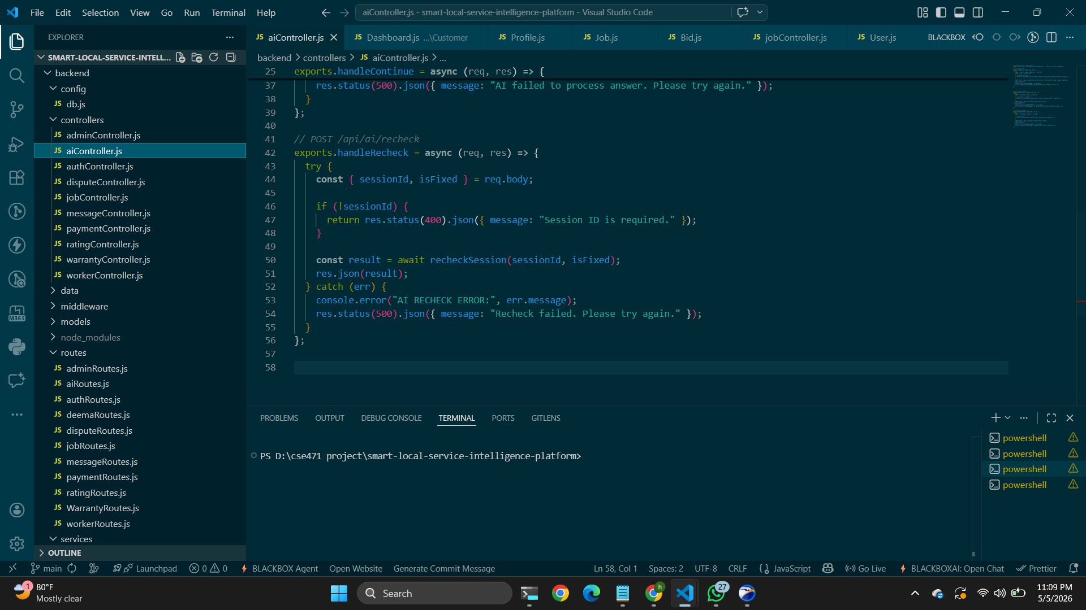

Api-4[saud]--- Groq api for ai support 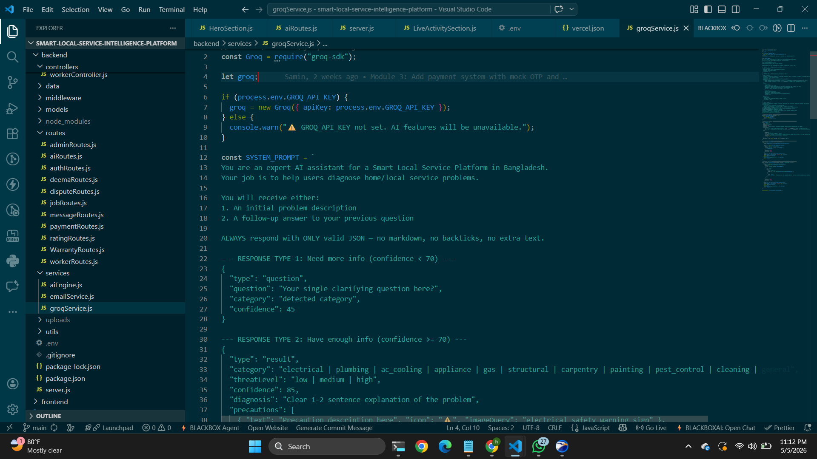
Api-5 [saud] ai routes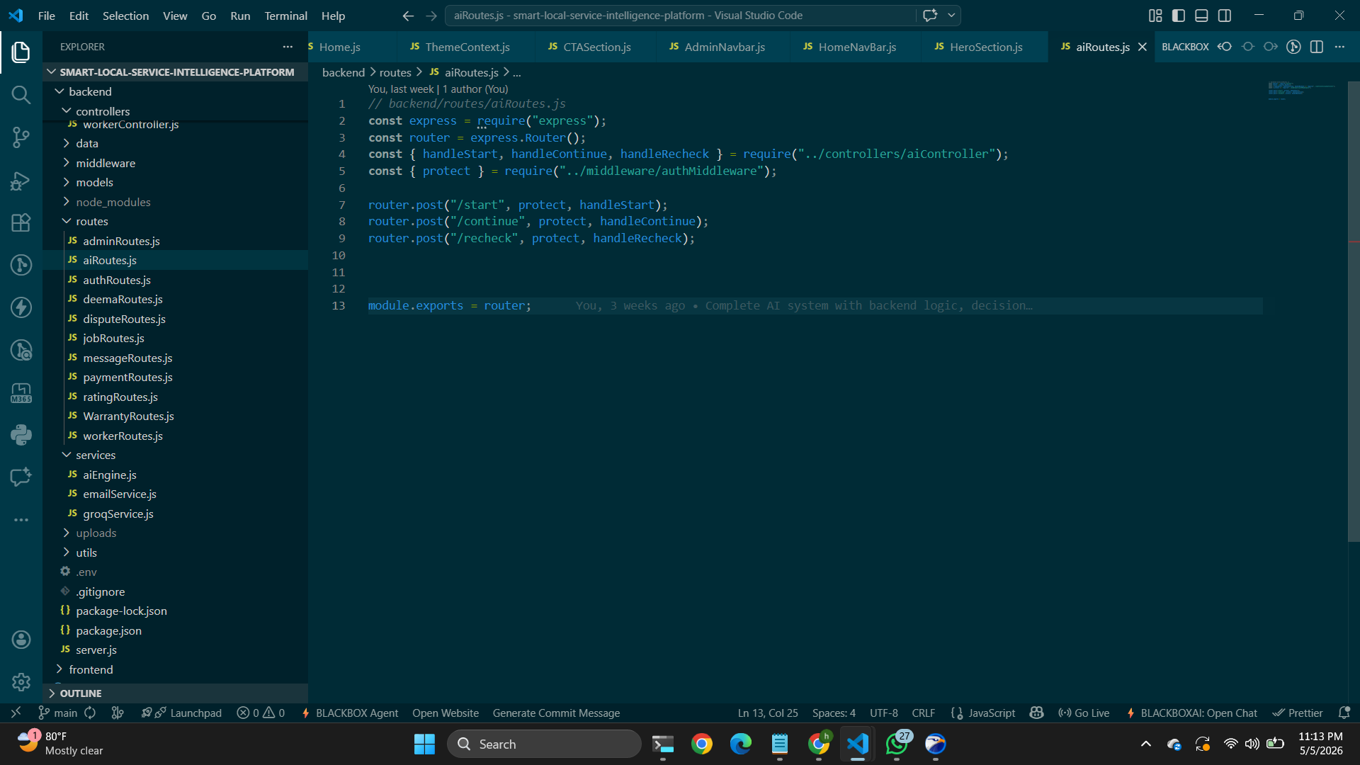
5. User Interface Design
Attach at least 5 interface designs generated in Figma. Attach the figma project link.
https://www.figma.com/proto/e0kAa4S63Iyx9H4ZCgQb8Y/Untitled?node-id=0-1&t=dCdXh8IW5giL5TQK-1 (Deema)

https://www.figma.com/design/IpYqdSx4BVY53dFPmj3IM3/Untitled?node-id=5-152&t=wB (Farhan Shahriar)
https://www.figma.com/design/p7qh4zRUaRsk2PTbuhKnf1/Untitled?node-id=0-1&t=oSAUFnVsB9PAwrL6-1 (Saud)
https://www.figma.com/proto/p7qh4zRUaRsk2PTbuhKnf1/Untitled?node-id=0-1&t=oSAUFnVsB9PAwrL6-1 (Saud)
6. Frontend Development
Attach at least 5 frontend code snippets with proper description.
DEEMA-
1) Cost Breakdown Component-
This component displays the itemized cost breakdown (labor, parts, urgency charges) fetched from the backend. It shows the total cost and allows users to review all charges before booking. The component calls the getCosts() API and renders a table showing each cost item with individual charges and the option to flag costs if the user disagrees with the pricing.
import React, { useState, useEffect } from "react";
import { getCosts } from "../api/system";
import "./CostBreakdown.css";
const CostBreakdown = () => {
const [costs, setCosts] = useState([]);
const [loading, setLoading] = useState(true);
const [error, setError] = useState(null);
useEffect(() => {
fetchCosts();
}, []);
const fetchCosts = async () => {
try {
const response = await getCosts();
setCosts(response.data);
setLoading(false);
} catch (err) {
setError("Failed to load costs");
setLoading(false);
}
};

if (loading) return <div className="loading">Loading cost details...</div>;
if (error) return <div className="error">{error}</div>;
return (
<div className="cost-breakdown-container">
<h2>Service Cost Breakdown</h2>
<table className="cost-table">
<thead>
<tr>
<th>Service Type</th>
<th>Labor Cost</th>
<th>Parts Cost</th>
<th>Urgency Charge</th>
<th>Total Cost</th>
<th>Action</th>
</tr>
</thead>
<tbody>
{costs.map((cost) => (
<tr key={cost._id} className={cost.flagged ? "flagged-row" : ""}>
<td>{cost.serviceType}</td>
<td>${cost.labor}</td>
<td>${cost.parts}</td>
<td>${cost.urgencyCharge}</td>
<td className="total-cost">${cost.totalCost}</td>
<td>
<button
className="flag-btn"
onClick={() => handleFlagClick(cost._id)}
>
{cost.flagged ? "Flagged" : "Flag Cost"}
</button>
</td>
</tr>
))}
</tbody>
</table>
</div>
);
};
export default CostBreakdown;
2)Warranty Display Component:
This component displays warranty information for a completed service job. It calls getWarrantyByJobId() API with the job ID and shows warranty details including expiry date, coverage terms, remaining claims, and active status. The component helps customers verify if their service is still under warranty protection and understand what is covered.
import React, { useState, useEffect } from "react";
import { getWarrantyByJobId } from "../api/system";
import "./WarrantyCard.css";
const WarrantyCard = ({ jobId }) => {
const [warranty, setWarranty] = useState(null);
const [loading, setLoading] = useState(true);
const [error, setError] = useState(null);
useEffect(() => {
fetchWarranty();
}, [jobId]);

const fetchWarranty = async () => {
try {
const response = await getWarrantyByJobId(jobId);
setWarranty(response.data);
setLoading(false);
} catch (err) {
setError("No warranty found for this service");
setLoading(false);
}
};
const isWarrantyActive = () => {
return warranty && new Date(warranty.expiryDate) > new Date();
};
const daysRemaining = () => {
if (!warranty) return 0;
const today = new Date();
const expiry = new Date(warranty.expiryDate);
const diff = expiry - today;
return Math.ceil(diff / (1000 * 60 * 60 * 24));
};
if (loading) return <div className="loading">Loading warranty info...</div>;
if (error) return <div className="error">{error}</div>;
if (!warranty) return <div className="no-warranty">No warranty available</div>;
return (
<div className={`warranty-card ${isWarrantyActive() ? "active" : "expired"}`}>
<div className="warranty-header">
<h3>Service Warranty</h3>
<span className={`status-badge ${isWarrantyActive() ? "active" : "expired"}`}>
{isWarrantyActive()? "Active" : "Expired"}
</span>
</div>
<div className="warranty-details">
<div className="detail-row">
<span className="label">Service Type:</span>
<span className="value">{warranty.serviceType}</span>
</div>
<div className="detail-row">
<span className="label">Start Date:</span>
<span className="value">{new Date(warranty.startDate).toLocaleDateString()}</span>
</div>
<div className="detail-row">
<span className="label">Expiry Date:</span>
<span className="value">{new Date(warranty.expiryDate).toLocaleDateString()}</span>
</div>
<div className="detail-row">
<span className="label">Duration:</span>
<span className="value">{warranty.warrantyDuration} months</span>
</div>
<div className="detail-row">
<span className="label">Days Remaining:</span>
<span className="value days-count">{daysRemaining()} days</span>
</div>
<div className="detail-row">
<span className="label">Claims Remaining:</span>
<span className="value">{warranty.claimsRemaining}</span>
</div>
</div>
<div className="coverage-section">
<h4>Coverage Includes:</h4>
<ul className="coverage-list">
{warranty.coverage.labor && <li>✓ Labor</li>}
{warranty.coverage.parts && <li>✓ Parts</li>}
{warranty.coverage.emergency_service && <li>✓ Emergency Service</li>}
</ul>
</div>
<div className="warranty-terms">
<p><strong>Terms:</strong> {warranty.terms}</p>
</div>
<button className="claim-btn">
{isWarrantyActive() ? "Submit Warranty Claim" : "Warranty Expired"}
</button>
</div>
);
};
export default WarrantyCard;
3)Dispute Submission Form Component:
This component provides a form for users to submit disputes regarding service quality or pricing. It collects dispute type, subject, detailed description, and allows users to upload multiple files (receipts, photos, invoices) as evidence. The component handles file selection, validates form data, and calls the createDispute() API with multipart/form-data to support file uploads.
import React, { useState } from "react";
import { createDispute } from "../api/system";
import "./DisputeForm.css"
const DisputeForm = ({ jobId, onSuccess }) => {
const [formData, setFormData] = useState({
jobId: jobId,
disputeType: "",
subject: "",
description: ""
});
const [files, setFiles] = useState([]);
const [loading, setLoading] = useState(false);
const [error, setError] = useState(null);
const [success, setSuccess] = useState(false);
const disputeTypes = [
{ value: "pricing", label: "Pricing Issue" },
{ value: "quality", label: "Service Quality" },
{ value: "incomplete", label: "Incomplete Service" },
{ value: "damage", label: "Property Damage" },
{ value: "other", label: "Other" }
];
const handleInputChange = (e) => {
const { name, value } = e.target;
setFormData({ ...formData, [name]: value });
};
const handleFileChange = (e) => {
const selectedFiles = Array.from(e.target.files);
if (selectedFiles.length > 5) {
setError("Maximum 5 files allowed");
return;
}
setFiles(selectedFiles);
setError(null);
};
const handleSubmit = async (e) => {
e.preventDefault();
if (!formData.disputeType || !formData.subject || !formData.description) {
setError("Please fill in all required fields");
return;
}
setLoading(true);
try {
const data = new FormData();
data.append("jobId", formData.jobId);
data.append("disputeType", formData.disputeType);
data.append("subject", formData.subject);
data.append("description", formData.description);
files.forEach((file) => {
data.append("attachments", file);
});
await createDispute(data);
setSuccess(true);
setFormData({ jobId, disputeType: "", subject: "", description: "" });
setFiles([]);
setTimeout(() => {
setSuccess(false);
onSuccess();
}, 2000);
} catch (err) {
setError("Failed to submit dispute. Please try again.");
} finally {
setLoading(false);
}
};
return (
<div className="dispute-form-container">
<h2>Submit a Dispute</h2>
<p className="form-description">
Let us know if you have concerns about the service provided or charges
</p>
{success && (
<div className="success-message">
✓ Dispute submitted successfully. Our team will review it within 24 hours.
</div>
)}
{error && <div className="error-message">{error}</div>}
<form onSubmit={handleSubmit}>
<div className="form-group">
<label>Dispute Type *</label>
<select
name="disputeType"
value={formData.disputeType}
onChange={handleInputChange}
required
>
<option value="">Select dispute type</option>
{disputeTypes.map((type) => (
<option key={type.value} value={type.value}>
{type.label}
</option>
))}
</select>
</div>
<div className="form-group">
<label>Subject *</label>
<input
type="text"
name="subject"
value={formData.subject}
onChange={handleInputChange}
placeholder="Brief title of your dispute"
required
/>
</div>
<div className="form-group">
<label>Detailed Description *</label>
<textarea
name="description"
value={formData.description}
onChange={handleInputChange}
placeholder="Please provide detailed information about your dispute..."
rows="5"
required
</option>
))}
</select>
</div>
<div className="form-group">
<label>Subject *</label>
<input
type="text"
name="subject"
value={formData.subject}
onChange={handleInputChange}
placeholder="Brief title of your dispute"
required
/>
</div>
<div className="form-group">
<label>Detailed Description *</label>
<textarea
name="description"
value={formData.description}
onChange={handleInputChange}
placeholder="Please provide detailed information about your dispute..."
rows="5"
required
</div>
<button
type="submit"
className="submit-btn"
disabled={loading}
>
{loading ? "Submitting..." : "Submit Dispute"}
</button>
</form>
</div>
);
};
export default DisputeForm;
4)Dispute Status Tracker Component:
This component displays a list of user's submitted disputes with status tracking. It calls getDisputes() API to fetch all disputes and shows dispute details including status, submission date, and admin updates. Users can click on a dispute to view full details including resolution information, compensation amount, and admin notes.
import React, { useState, useEffect } from "react";
import { getDisputes, getDispute } from "../api/system";
import DisputeDetail from "./DisputeDetail";
import "./DisputeTracker.css";
const DisputeTracker = () => {
const [disputes, setDisputes] = useState([]);
const [loading, setLoading] = useState(true);
const [error, setError] = useState(null);
const [selectedDispute, setSelectedDispute] = useState(null);
const [showDetail, setShowDetail] = useState(false);
useEffect(() => {
fetchDisputes();
}, []);
const fetchDisputes = async () => {
try {
const response = await getDisputes();
setDisputes(response.data);
setLoading(false);
} catch (err) {
setError("Failed to load disputes");
setLoading(false);
}
};
const handleViewDetail = async (disputeId) => {
try {
const response = await getDispute(disputeId);
setSelectedDispute(response.data);
setShowDetail(true);
} catch (err) {
setError("Failed to load dispute details");
}
};
const getStatusColor = (status) => {
switch (status) {
case "Submitted":
return "status-submitted";
case "Under Review":
return "status-review";
case "Resolved":
return "status-resolved";
case "Rejected":
return "status-rejected";
default:
return "status-default";
}
};
const getStatusIcon = (status) => {
switch (status) {
case "Submitted":
return "📋";
case "Under Review":
return "🔍";
case "Resolved":
return "✓";
case "Rejected":
return "✗";
default:
return "•";
}
};
if (loading) return <div className="loading">Loading disputes...</div>;
if (error) return <div className="error">{error}</div>;
if (showDetail && selectedDispute) {
return (
<DisputeDetail
dispute={selectedDispute}
onBack={() => setShowDetail(false)}
/>
);
}
return (
<div className="dispute-tracker-container">
<h2>My Disputes</h2>
case "Under Review":
return "🔍";
case "Resolved":
return "✓";
case "Rejected":
return "✗";
default:
return "•";
}
};
if (loading) return <div className="loading">Loading disputes...</div>;
if (error) return <div className="error">{error}</div>;
if (showDetail && selectedDispute) {
return (
<DisputeDetail
dispute={selectedDispute}
onBack={() => setShowDetail(false)}
/>
);
}
return (
<div className="dispute-tracker-container">
<h2>My Disputes</h2>
)}
</div>
<div className="dispute-footer">
{dispute.status === "Resolved" && dispute.compensationAmount > 0 && (
<div className="compensation-info">
💰 Refund: ${dispute.compensationAmount}
</div>
)}
<button
className="view-detail-btn"
onClick={() => handleViewDetail(dispute._id)}
>
View Details →
</button>
</div>
</div>
))}
</div>
)}
</div>
);
};
export default DisputeTracker
5)Dispute Detail View Component:
This component displays the complete details of a specific dispute including the full description, all attached files, admin resolution information, and compensation details. It's shown when a user clicks "View Details" on a dispute card. The component fetches detailed dispute information using getDispute() API and displays a timeline of dispute progression from submission to resolution.
import React, { useState, useEffect } from "react";
import { getDispute } from "../api/system";
import "./DisputeDetail.css";
const DisputeDetail = ({ disputeId, onBack }) => {
const [dispute, setDispute] = useState(null);
const [loading, setLoading] = useState(true);
const [error, setError] = useState(null);
const [expandedAttachments, setExpandedAttachments] = useState(false);
useEffect(() => {
fetchDisputeDetail();
}, [disputeId]);
const fetchDisputeDetail = async () => {
try {
const response = await getDispute(disputeId);
setDispute(response.data);
setLoading(false);
} catch (err) {
setError("Failed to load dispute details");
setLoading(false);
}
};
const getStatusProgressPercentage = () => {
const statusMap = {
"Submitted": 25,
"Under Review": 50,
"Resolved": 100,
"Rejected": 75
};
return statusMap[dispute?.status] || 0;
};
const formatDate = (dateString) => {
const options = { year: 'numeric', month: 'long', day: 'numeric', hour: '2-digit', minute: '2-digit' };
return new Date(dateString).toLocaleDateString('en-US', options);
};
if (loading) return <div className="loading">Loading dispute details...</div>;
if (error) return <div className="error">{error}</div>;
if (!dispute) return <div className="error">Dispute not found</div>;
return (
<div className="dispute-detail-container">
<button className="back-btn" onClick={onBack}>← Back to Disputes</button>
<div className="detail-header">
<div className="header-title">
<h2>{dispute.subject}</h2>
<span className={`status-badge-large status-${dispute.status.toLowerCase()}`}>
{dispute.status}
</span>
</div>
<div className="header-meta">
<p>Dispute ID: <code>{dispute._id}</code></p>
<p>Job ID: <code>{dispute.jobId}</code></p>
<p>Type: <strong>{dispute.disputeType.toUpperCase()}</strong></p>
</div>
</div>
{/* Progress Timeline */}
<div className="progress-section">
<h3>Dispute Progress</h3>
<div className="progress-bar">
<div
className="progress-fill"
style={{ width: `${getStatusProgressPercentage()}%` }}
/>
</div>
<div className="timeline">
<div className={`timeline-item ${dispute.status === "Submitted" || true ? "completed" : ""}`}>
<span className="timeline-dot">1</span>
<span className="timeline-label">Submitted</span>
<span className="timeline-date">{formatDate(dispute.createdAt)}</span>
</div>
<div className={`timeline-item ${["Under Review", "Resolved", "Rejected"].includes(dispute.status) ? "completed" : ""}`}>
<span className="timeline-dot">2</span>
<span className="timeline-label">Under Review</span>
</div>
<div className={`timeline-item ${["Resolved", "Rejected"].includes(dispute.status) ? "completed" : ""}`}>
<span className="timeline-dot">3</span>
<span className="timeline-label">Resolved</span>
{dispute.resolvedAt && <span className="timeline-date">{formatDate(dispute.resolvedAt)}</span>}
</div>
</div>
</div>

{/* Dispute Details */}
<div className="details-section">
<h3>Dispute Details</h3>
<div className="detail-box">
<h4>Your Description:</h4>
<p className="description-text">{dispute.description}</p>
</div>
</div>
{/* Attachments */}
{dispute.attachments && dispute.attachments.length > 0 && (
<div className="attachments-section">
<h3>Attached Evidence ({dispute.attachmentCount} files)</h3>
<button
className="toggle-attachments-btn"
onClick={() => setExpandedAttachments(!expandedAttachments)}
>
{expandedAttachments ? "Hide Files" : "Show Files"}
</button>

{expandedAttachments && (
<div className="attachments-list">
{dispute.attachments.map((attachment, idx) => (
<div key={idx} className="attachment-item">
<div className="attachment-info">
<span className="file-icon">📄</span>
<div className="file-details">
<p className="file-name">{attachment.filename}</p>
<p className="file-size">{(attachment.size / 1024).toFixed(2)} KB</p>
</div>
</div>
<a
href={`http://localhost:5000${attachment.path}`}
target="_blank"
rel="noopener noreferrer"
className="download-btn"
>
Download
</a>
</div>
))}
</div>
)}
</div>
)}
{/* Admin Response */}
{dispute.status === "Resolved" || dispute.status === "Rejected" ? (
<div className="resolution-section">
<h3>Admin Response</h3>
<div className={`resolution-box resolution-${dispute.status.toLowerCase()}`}>
<div className="resolution-header">
<h4>Resolution: <strong>{dispute.resolution}</strong></h4>
<p className="resolved-by">
Resolved by: {dispute.resolvedBy} on {formatDate(dispute.resolvedAt)}
</p>
</div>

<div className="resolution-details">
{dispute.compensationAmount > 0 && (
<div className="compensation-box">
<span className="comp-label">💰 Compensation Approved:</span>
<span className="comp-amount">${dispute.compensationAmount}</span>
</div>
)}

{dispute.notes && (
<div className="notes-box">
<h5>Admin Notes:</h5>
<p>{dispute.notes}</p>
</div>
)}
</div>
</div>
</div>
) : (
<div className="pending-resolution">
<p>⏳ This dispute is still being reviewed. Please check back soon for updates.</p>
</div>
)}
{/* Action Buttons */}
<div className="action-buttons">
{dispute.status === "Resolved" && (
<button className="accept-btn">✓ Accept Resolution</button>
)}
{dispute.status === "Rejected" && (
<button className="appeal-btn">🔄 Submit Appeal</button>
)}
<button className="print-btn">🖨️ Print Details</button>
</div>
</div>
);
};
export default DisputeDetail;
FARHAN-
1)Worker Profile Management Component-:
This component allows workers to create and edit their complete profile including skills, experience, service area, and hourly rate. It's a comprehensive form that collects all necessary information for the worker profile. The component validates inputs, handles file uploads for profile pictures, and calls the createWorkerProfile() API to save profile data.
import React, { useState, useEffect } from "react";
import { createWorkerProfile, getWorkerProfile } from "../api/system";
import "./WorkerProfileForm.css";

const WorkerProfileForm = ({ userId, onSuccess }) => {
const [formData, setFormData] = useState({
name: "",
skills: [],
experience: "",
hourlyRate: "",
bio: "",
certifications: []
});
const [serviceArea, setServiceArea] = useState({
city: "",
state: "",
zipCode: "",
radius: 15
});
const [newSkill, setNewSkill] = useState("");
const [newCert, setNewCert] = useState("");
const [loading, setLoading] = useState(false);
const [error, setError] = useState(null);
const [success, setSuccess] = useState(false);

useEffect(() => {
fetchProfile();
}, [userId]);

const fetchProfile = async () => {
try {
const response = await getWorkerProfile(userId);
if (response.data) {
setFormData(response.data);
setServiceArea(response.data.serviceArea);
}
} catch (err) {
console.log("No existing profile found");
}
};

const handleInputChange = (e) => {
const { name, value } = e.target;
setFormData({ ...formData, [name]: value });
};

const handleServiceAreaChange = (e) => {
const { name, value } = e.target;
setServiceArea({ ...serviceArea, [name]: value });
};

const addSkill = () => {
if (newSkill.trim() && !formData.skills.includes(newSkill)) {
setFormData({
...formData,
skills: [...formData.skills, newSkill.trim()]
});
setNewSkill("");
}
};

const removeSkill = (skillToRemove) => {
setFormData({
...formData,
skills: formData.skills.filter((skill) => skill !== skillToRemove)
});
};

const addCertification = () => {
if (newCert.trim() && !formData.certifications.includes(newCert)) {
setFormData({
...formData,
certifications: [...formData.certifications, newCert.trim()]
});
setNewCert("");
}
};

const removeCertification = (certToRemove) => {
setFormData({
...formData,
certifications: formData.certifications.filter(
(cert) => cert !== certToRemove
)
});
};

const handleSubmit = async (e) => {
e.preventDefault();

if (!formData.name || formData.skills.length === 0 || !serviceArea.city) {
setError("Please fill in all required fields");
return;
}
setLoading(true);
try {
const profileData = {
userId,
...formData,
serviceArea
};
await createWorkerProfile(profileData);
setSuccess(true);
setTimeout(() => {
setSuccess(false);
onSuccess();
}, 2000);
} catch (err) {
setError("Failed to save profile. Please try again.");
} finally {
setLoading(false);
}
};
return (
<div className="worker-profile-form-container">
<h2>Complete Your Profile</h2>
<p className="form-description">
Help customers find you by completing your professional profile
</p>
{success && (
<div className="success-message">
✓ Profile saved successfully!
</div>
)}
{error && <div className="error-message">{error}</div>}
<form onSubmit={handleSubmit}>
{/* Basic Information */}
<section className="form-section">
<h3>Basic Information</h3>
<div className="form-group">
<label>Full Name *</label>
<input
type="text"
name="name"
value={formData.name}
onChange={handleInputChange}
placeholder="Enter your full name"
required
/>
</div>

<div className="form-group">
<label>Years of Experience *</label>
<input
type="number"
name="experience"
value={formData.experience}
onChange={handleInputChange}
placeholder="e.g., 8"
required
/>
</div>

<div className="form-group">
<label>Hourly Rate ($) *</label>
<input
type="number"
name="hourlyRate"
value={formData.hourlyRate}
onChange={handleInputChange}
placeholder="e.g., 65"
required
/>
</div>

<div className="form-group">
<label>Professional Bio</label>
<textarea
name="bio"
value={formData.bio}
onChange={handleInputChange}
placeholder="Tell customers about your expertise and experience"
rows="4"
/>
</div>
</section>

{/* Skills */}
<section className="form-section">
<h3>Skills *</h3>
<div className="skill-input-group">
<input
type="text"
value={newSkill}
onChange={(e) => setNewSkill(e.target.value)}
placeholder="e.g., Plumbing, Electrical work"
onKeyPress={(e) => e.key === "Enter" && (e.preventDefault(), addSkill())}
/>
<button type="button" onClick={addSkill} className="add-btn">
Add Skill
</button>
</div>
<div className="skills-list">
{formData.skills.map((skill, idx) => (
<div key={idx} className="skill-tag">
<span>{skill}</span>
<button
type="button"
onClick={() => removeSkill(skill)}
className="remove-btn"
>
×
</button>
</div>
))}
</div>
{formData.skills.length === 0 && (
<p className="help-text">Add at least one skill</p>
)}
</section>

{/* Certifications */}
<section className="form-section">
<h3>Certifications & Licenses</h3>
<div className="cert-input-group">
<input
type="text"
value={newCert}
onChange={(e) => setNewCert(e.target.value)}
placeholder="e.g., Master Plumber License"
onKeyPress={(e) => e.key === "Enter" && (e.preventDefault(), addCertification())}
/>
<button type="button" onClick={addCertification} className="add-btn">
Add Certification
</button>
</div>

<div className="certs-list">
{formData.certifications.map((cert, idx) => (
<div key={idx} className="cert-tag">
<span>📜 {cert}</span>
<button
type="button"
onClick={() => removeCertification(cert)}
className="remove-btn"
>
×
</button>
</div>
))}
</div>
</section>

{/* Service Area */}
<section className="form-section">
<h3>Service Area *</h3>

<div className="form-row">
<div className="form-group">
<label>City *</label>
<input
type="text"
name="city"
value={serviceArea.city}
onChange={handleServiceAreaChange}
placeholder="e.g., New York"
required
/>
</div>

<div className="form-group">
<label>State *</label>
<input
type="text"
name="state"
value={serviceArea.state}
onChange={handleServiceAreaChange}
placeholder="e.g., NY"
required
/>
</div>

<div className="form-group">
<label>ZIP Code</label>
<input
type="text"
name="zipCode"
value={serviceArea.zipCode}
onChange={handleServiceAreaChange}
placeholder="10001"
/>
</div>
</div>

<div className="form-group">
<label>Service Radius (miles)</label>
<input
type="number"
name="radius"
value={serviceArea.radius}
onChange={handleServiceAreaChange}
placeholder="15"
/>
</div>
</section>
<button
type="submit"
className="submit-btn"
disabled={loading}
>
{loading ? "Saving..." : "Save Profile"}
</button>
</form>
</div>
);
}
export default WorkerProfileForm;
2)Worker Availability Status Component:
This component allows workers to quickly update their real-time availability status (available, busy, offline). It displays the current status with visual indicators and provides quick toggle buttons to change status. The component calls the updateWorkerAvailability() API to update the status in real-time, allowing customers to see which workers are available to accept new requests.
import React, { useState, useEffect } from "react";
import { updateWorkerAvailability, getWorkerProfile } from "../api/system";
import "./AvailabilityStatus.css";
const AvailabilityStatus = ({ workerId }) => {
const [availability, setAvailability] = useState("available");
const [loading, setLoading] = useState(false);
const [lastUpdate, setLastUpdate] = useState(null);
useEffect(() => {
fetchAvailability();
}, [workerId]);
const fetchAvailability = async () => {
try {
const response = await getWorkerProfile(workerId);
setAvailability(response.data.availability);
setLastUpdate(response.data.lastAvailabilityUpdate);
} catch (error) {
console.error("Failed to fetch availability");
}
};

const handleStatusChange = async (newStatus) => {
setLoading(true);
try {
await updateWorkerAvailability(workerId, newStatus);
setAvailability(newStatus);
setLastUpdate(new Date());
} catch (error) {
console.error("Failed to update availability");
} finally {
setLoading(false);
}
};
const getStatusColor = () => {
switch (availability) {
case "available":
return "status-available";
case "busy":
return "status-busy";
case "offline":
return "status-offline";
default:
return "status-default";
}
};

const getStatusIcon = () => {
switch (availability) {
case "available":
return "🟢";
case "busy":
return "🟡";
case "offline":
return "🔴";
default:
return "⚪";
}
};

const formatLastUpdate = () => {
if (!lastUpdate) return "Never";
const date = new Date(lastUpdate);
const now = new Date();
const diffSeconds = Math.floor((now - date) / 1000);

if (diffSeconds < 60) return "Just now";
if (diffSeconds < 3600) return `${Math.floor(diffSeconds / 60)} minutes ago`;
if (diffSeconds < 86400) return `${Math.floor(diffSeconds / 3600)} hours ago`;
return date.toLocaleDateString();
};

return (
<div className="availability-container">
<div className="availability-card">
<div className="availability-header">
<h3>Your Availability Status</h3>
<span className={`status-badge ${getStatusColor()}`}>
{getStatusIcon()} {availability.toUpperCase()}
</span>
</div>

<p className="last-update">
Last updated: {formatLastUpdate()}
</p>

<div className="status-info">
<p>
{availability === "available" &&
"✓ You are accepting new service requests"}
{availability === "busy" &&
"⏳ You are busy with current jobs, but customers can still request"}
{availability === "offline" &&
"✗ You are offline and not accepting requests"}
</p>
</div>

<div className="status-buttons">
<button
className={`status-btn available-btn ${availability === "available" ? "active" : ""}`}
onClick={() => handleStatusChange("available")}
disabled={loading}
>
🟢 Available
</button>
<button
className={`status-btn busy-btn ${availability === "busy" ? "active" : ""}`}
onClick={() => handleStatusChange("busy")}
disabled={loading}
>
🟡 Busy
</button>
<button
className={`status-btn offline-btn ${availability === "offline" ? "active" : ""}`}
onClick={() => handleStatusChange("offline")}
disabled={loading}
>
🔴 Offline
</button>
</div>
{loading && <p className="loading-text">Updating status...</p>}
<div className="status-legend">
<div className="legend-item">
<span className="legend-icon">🟢</span>
<p>Available - Ready to accept new requests</p>
</div>
<div className="legend-item">
<span className="legend-icon">🟡</span>
<p>Busy - Working on current jobs, limited availability</p>
</div>
<div className="legend-item">
<span className="legend-icon">🔴</span>
<p>Offline - Not available to accept requests</p>
</div>
</div>
</div>
</div>
);
};
export default AvailabilityStatus;
3)Worker Discovery and Filtering Component:
This component displays a list of workers filtered by location, skills, and availability. It calls the filterWorkers() API with the user's location coordinates and desired skills, then displays results in a card format showing worker ratings, reviews, hourly rates, and distance. The component includes skill filters, sorting options, and interactive cards with worker details.
import React, { useState, useEffect } from "react";
import { filterWorkers } from "../api/system";
import WorkerCard from "./WorkerCard";
import "./WorkerDiscovery.css";

const WorkerDiscovery = ({ userLocation }) => {
const [workers, setWorkers] = useState([]);
const [loading, setLoading] = useState(true);
const [error, setError] = useState(null);
const [selectedSkill, setSelectedSkill] = useState("");
const [sortBy, setSortBy] = useState("rating");
const [availability, setAvailability] = useState("available");

const skills = [
"Plumbing",
"Electrical",
"HVAC",
"Carpentry",
"Painting",
"Roofing",
"Landscaping",
"Cleaning"
];

useEffect(() => {
fetchWorkers();
}, [selectedSkill, availability, userLocation]);
const fetchWorkers = async () => {
setLoading(true);
try {
const params = {
latitude: userLocation.latitude,
longitude: userLocation.longitude,
skill: selectedSkill || undefined,
availability
};

const response = await filterWorkers(params);
setWorkers(response.data.workers);
setError(null);
} catch (err) {
setError("Failed to load workers. Please try again.");
setWorkers([]);
} finally {
setLoading(false);
}
};

const sortedWorkers = [...workers].sort((a, b) => {
switch (sortBy) {
case "rating":
return b.rating - a.rating;
case "distance":
return a.distance - b.distance;
case "price":
return a.hourlyRate - b.hourlyRate;
default:
return 0;
}
});

if (loading) return <div className="loading">Loading workers...</div>;
if (error) return <div className="error">{error}</div>;

return (
<div className="worker-discovery-container">
<h2>Find the Right Worker for Your Job</h2>

{/* Filters Section */}
<div className="filters-section">
<div className="filter-group">
<label>Service Type</label>
<select
value={selectedSkill}
onChange={(e) => setSelectedSkill(e.target.value)}
className="filter-select"
>
<option value="">All Services</option>
{skills.map((skill) => (
<option key={skill} value={skill}>
{skill}
</option>
))}
</select>
</div>

<div className="filter-group">
<label>Availability</label>
<select
value={availability}
onChange={(e) => setAvailability(e.target.value)}
className="filter-select"
>
<option value="">All</option>
<option value="available">Available Now</option>
<option value="busy">Busy (Can Request)</option>
</select>
</div>

<div className="filter-group">
<label>Sort By</label>
<select
value={sortBy}
onChange={(e) => setSortBy(e.target.value)}
className="filter-select"
>
<option value="rating">Top Rated</option>
<option value="distance">Closest First</option>
<option value="price">Lowest Price</option>
</select>
</div>
</div>

{/* Results Count */}
<div className="results-info">
<p>
Found <strong>{sortedWorkers.length}</strong> worker(s)
{selectedSkill && ` for ${selectedSkill}`}
</p>
</div>

{/* Workers Grid */}
{sortedWorkers.length === 0 ? (
<div className="no-results">
<p>No workers found matching your criteria.</p>
<p>Try adjusting your filters or location.</p>
</div>
) : (
<div className="workers-grid">
{sortedWorkers.map((worker) => (
<WorkerCard key={worker._id} worker={worker} />
))}
</div>
)}
</div>
);
};
export default WorkerDiscovery;
4)Ratings and Review Component:
This component displays a review form for customers to rate and review workers after service completion. It shows a 5-star rating system, allows text feedback, and displays existing reviews from other customers. The component calls the submitReview() API to submit ratings and updates the worker's overall rating and review count in real-time.
import React, { useState, useEffect } from "react";
import { submitReview, getWorkerReviews } from "../api/system";
import "./WorkerRatings.css";
const WorkerRatings = ({ workerId, workerName, requestId, onReviewSubmitted }) => {
const [reviews, setReviews] = useState([]);
const [ratingDistribution, setRatingDistribution] = useState({});
const [loading, setLoading] = useState(true);
const [submitting, setSubmitting] = useState(false);
const [error, setError] = useState(null);
const [success, setSuccess] = useState(false);

const [formData, setFormData] = useState({
rating: 5,
title: "",
feedback: ""
});

useEffect(() => {
fetchReviews();
}, [workerId]);

const fetchReviews = async () => {
try {
const response = await getWorkerReviews(workerId);
setReviews(response.data.reviews);
setRatingDistribution(response.data.ratingDistribution);
setLoading(false);
} catch (err) {
setError("Failed to load reviews");
setLoading(false);
}
};
const handleSubmit = async (e) => {
e.preventDefault();
if (!formData.title.trim() || !formData.feedback.trim()) {
setError("Please provide both title and feedback");
return;
}
setSubmitting(true);
try {
const reviewData = {
workerId,
requestId,
rating: formData.rating,
title: formData.title,
feedback: formData.feedback
};

await submitReview(reviewData);
setSuccess(true);

// Fetch updated reviews
setTimeout(() => {
fetchReviews();
setSuccess(false);
setFormData({
rating: 5,
title: "",
feedback: ""
});
onReviewSubmitted();
}, 2000);
} catch (err) {
setError("Failed to submit review. Please try again.");
} finally {
setSubmitting(false);
}
};

const getRatingColor = (rating) => {
if (rating >= 4.5) return "excellent";
if (rating >= 4) return "very-good";
if (rating >= 3) return "good";
return "poor";
};

const overallRating = reviews.length > 0
? (reviews.reduce((sum, r) => sum + r.rating, 0) / reviews.length).toFixed(1)
: 0;
if (loading) return <div className="loading">Loading reviews...</div>;

return (
<div className="worker-ratings-container">
<h2>Ratings & Reviews for {workerName}</h2>

{/* Overall Rating Summary */}
<div className="rating-summary">
<div className="overall-rating">
<div className="rating-number">{overallRating}</div>
<div className="rating-stars">
{"⭐".repeat(Math.round(overallRating))}
</div>
<p className="review-count">
Based on {reviews.length} review{reviews.length !== 1 ? "s" : ""}
</p>
</div>

{/* Rating Distribution */}
<div className="rating-distribution">
{[5, 4, 3, 2, 1].map((rating) => (
<div key={rating} className="distribution-bar">
<span className="stars-label">{rating} ⭐</span>
<div className="bar-background">
<div
className="bar-fill"
style={{
width: `${
reviews.length > 0
? ((ratingDistribution[rating] || 0) / reviews.length) * 100
: 0
}%`
}}
/>
</div>
<span className="count">
{ratingDistribution[rating] || 0}
</span>
</div>
))}
</div>
</div>

{/* Submit Review Form */}
{requestId && (
<div className="review-form-section">
<h3>Share Your Experience</h3>

{success && (
<div className="success-message">
✓ Thank you! Your review has been published.
</div>
)}
{error && <div className="error-message">{error}</div>}

<form onSubmit={handleSubmit}>
{/* Star Rating */}
<div className="form-group">
<label>Your Rating *</label>
<div className="star-rating">
{[1, 2, 3, 4, 5].map((star) => (
<button
key={star}
type="button"
className={`star ${formData.rating >= star ? "active" : ""}`}
onClick={() => setFormData({ ...formData, rating: star })}
>
⭐
</button>
))}
</div>
<p className="rating-feedback">
{formData.rating === 5 && "Excellent service!"}
{formData.rating === 4 && "Very good service"}
{formData.rating === 3 && "Good service"}
{formData.rating === 2 && "Could be better"}
{formData.rating === 1 && "Poor service"}
</p>
</div>
{/* Review Title */}
<div className="form-group">
<label>Review Title *</label>
<input
type="text"
value={formData.title}
onChange={(e) => setFormData({ ...formData, title: e.target.value })}
placeholder="e.g., Professional and Quick Service"
maxLength="100"
required
/>
<p className="char-count">
{formData.title.length}/100
</p>
</div>
{/* Feedback */}
<div className="form-group">
<label>Your Feedback *</label>
<textarea
value={formData.feedback}
onChange={(e) => setFormData({ ...formData, feedback: e.target.value })}
placeholder="Share details about your experience with this worker..."
rows="4"
maxLength="500"
required
/>
<p className="char-count">
{formData.feedback.length}/500
</p>
</div>
<button
type="submit"
className="submit-btn"
disabled={submitting}
>
{submitting ? "Submitting..." : "Submit Review"}
</button>
</form>
</div>
)}

{/* Recent Reviews */}
<div className="reviews-list-section">
<h3>Recent Reviews ({reviews.length})</h3>
{reviews.length === 0 ? (
<p className="no-reviews">No reviews yet. Be the first to review!</p>
) : (
<div className="reviews-list">
{reviews.slice(0, 5).map((review) => (
<div key={review._id} className="review-item">
<div className="review-header">
<div className="review-meta">
<p className="review-title">{review.title}</p>
<span className="review-rating">
{"⭐".repeat(review.rating)}
</span>
</div>
<p className="review-date">
{new Date(review.createdAt).toLocaleDateString()}
</p>
</div>
<p className="review-feedback">{review.feedback}</p>
</div>
))}
</div>
)}
</div>
</div>
);
};
export default WorkerRatings;
5) Messaging component : allows users to communicate through texts and calls
import React, { useState, useEffect, useRef, useContext } from 'react';
import { sendMessage, getConversation } from '../api/messages';
import { AuthContext } from '../context/AuthContext';
import { io } from 'socket.io-client';

const ChatModal = ({ isOpen, onClose, otherUserId, otherUserName, otherUserPicture, onMessageSent }) => {
const [messages, setMessages] = useState([]);
const [messageText, setMessageText] = useState('');
const [loading, setLoading] = useState(false);
const [error, setError] = useState('');
const messagesEndRef = useRef(null);
const socketRef = useRef(null);
const { user } = useContext(AuthContext);

// Scroll to bottom when messages change
const scrollToBottom = () => {
messagesEndRef.current?.scrollIntoView({ behavior: 'smooth' });
};

useEffect(() => {
scrollToBottom();
}, [messages]);

// Initialize Socket.io connection
useEffect(() => {
if (!socketRef.current) {
const socket = io(process.env.REACT_APP_API_URL || 'http://localhost:5000', {
reconnection: true,
reconnectionDelay: 1000,
reconnectionDelayMax: 5000,
reconnectionAttempts: 5
});

socket.on('connect', () => {
console.log('Connected to Socket.io');
// Join user's room
socket.emit('join', user?.id);
});

socket.on('receiveMessage', (data) => {
setMessages(prev => [...prev, {
senderId: { _id: data.senderId },
receiverId: { _id: data.receiverId },
message: data.message,
timestamp: new Date(data.timestamp)
}]);
});

socket.on('disconnect', () => {
console.log('Disconnected from Socket.io');
});

socketRef.current = socket;
}

return () => {
// Cleanup is handled when component unmounts
};
}, [user?.id]);

// Load conversation when modal opens
useEffect(() => {
if (isOpen && otherUserId) {
loadConversation();
}
}, [isOpen, otherUserId]);

const loadConversation = async () => {
try {
setLoading(true);
const data = await getConversation(otherUserId);
setMessages(data);
setError('');
} catch (err) {
console.error('Error loading conversation:', err);
} finally {
setLoading(false);
}
};

const handleSendMessage = async (e) => {
e.preventDefault();

if (!messageText.trim()) {
return;
}

setLoading(true);
try {
// Send message to database
await sendMessage(otherUserId, messageText);

// Emit via Socket.io for real-time delivery
if (socketRef.current) {
socketRef.current.emit('sendMessage', {
senderId: user?.id,
receiverId: otherUserId,
message: messageText.trim(),
timestamp: new Date()
});
}

setMessageText('');
setError('');

// Reload conversation to ensure we have the latest
await loadConversation();

// Call callback to refresh conversations list
if (onMessageSent) {
onMessageSent();
}
} catch (err) {
setError('Failed to send message. Please try again.');
console.error('Error sending message:', err);
} finally {
setLoading(false);
}
};

if (!isOpen) return null;

const isCurrentUserSender = (senderObj) => {
return senderObj?._id === user?.id;
};

return (
<div className="fixed inset-0 bg-black bg-opacity-50 flex items-center justify-center z-50">
<div className="bg-white rounded-lg shadow-2xl w-full max-w-md h-[600px] flex flex-col">
{/* Header */}
<div className="bg-cyan-500 text-white p-4 flex items-center justify-between rounded-t-lg">
<div className="flex items-center space-x-3">
<img
src={otherUserPicture || 'https://via.placeholder.com/40'}
alt={otherUserName}
className="w-10 h-10 rounded-full"
/>
<div>
<h2 className="font-semibold">{otherUserName}</h2>
<p className="text-xs opacity-90">Online</p>
</div>
</div>
<button
onClick={onClose}
className="text-white hover:bg-cyan-600 rounded-full p-1 transition"
>
<svg className="w-6 h-6" fill="none" stroke="currentColor" viewBox="0 0 24 24">
<path strokeLinecap="round" strokeLinejoin="round" strokeWidth={2} d="M6 18L18 6M6 6l12 12" />
</svg>
</button>
</div>

{/* Messages Container */}
<div className="flex-1 overflow-y-auto p-4 bg-gray-50 space-y-4">
{messages.length === 0 ? (
<div className="text-center text-gray-500 mt-8">
<p>No messages yet. Start the conversation!</p>
</div>
) : (
messages.map((msg, index) => {
const isFromCurrentUser = isCurrentUserSender(msg.senderId);
return (
<div
key={index}
className={`flex ${isFromCurrentUser ? 'justify-end' : 'justify-start'}`}
>
<div
className={`max-w-xs lg:max-w-md xl:max-w-lg px-4 py-2 rounded-lg ${
isFromCurrentUser
? 'bg-cyan-500 text-white rounded-br-none'
: 'bg-gray-300 text-gray-900 rounded-bl-none'
}`}
>
<p className="text-sm">{msg.message}</p>
<p className={`text-xs ${isFromCurrentUser ? 'text-cyan-100' : 'text-gray-600'} mt-1`}>
{new Date(msg.timestamp).toLocaleTimeString([], {
hour: '2-digit',
minute: '2-digit'
})}
</p>
</div>
</div>
);
})
)}
<div ref={messagesEndRef} />
</div>

{/* Error Message */}
{error && (
<div className="px-4 py-2 bg-red-100 text-red-700 text-sm">
{error}
</div>
)}

{/* Input */}
<form onSubmit={handleSendMessage} className="border-t p-4 bg-white rounded-b-lg">
<div className="flex space-x-2">
<input
type="text"
value={messageText}
onChange={(e) => setMessageText(e.target.value)}
placeholder="Type a message..."
className="flex-1 border border-gray-300 rounded-lg px-3 py-2 text-black focus:outline-none focus:ring-2 focus:ring-cyan-500"
disabled={loading}
/>
<button
type="submit"
disabled={loading || !messageText.trim()}
className="bg-cyan-500 text-white px-4 py-2 rounded-lg hover:bg-cyan-600 transition disabled:bg-gray-400 disabled:cursor-not-allowed font-medium"
>
{loading ? 'Sending...' : 'Send'}
</button>
</div>
</form>
</div>
</div>
);
};

export default ChatModal;

.

Saud frontend snapshots

Apis-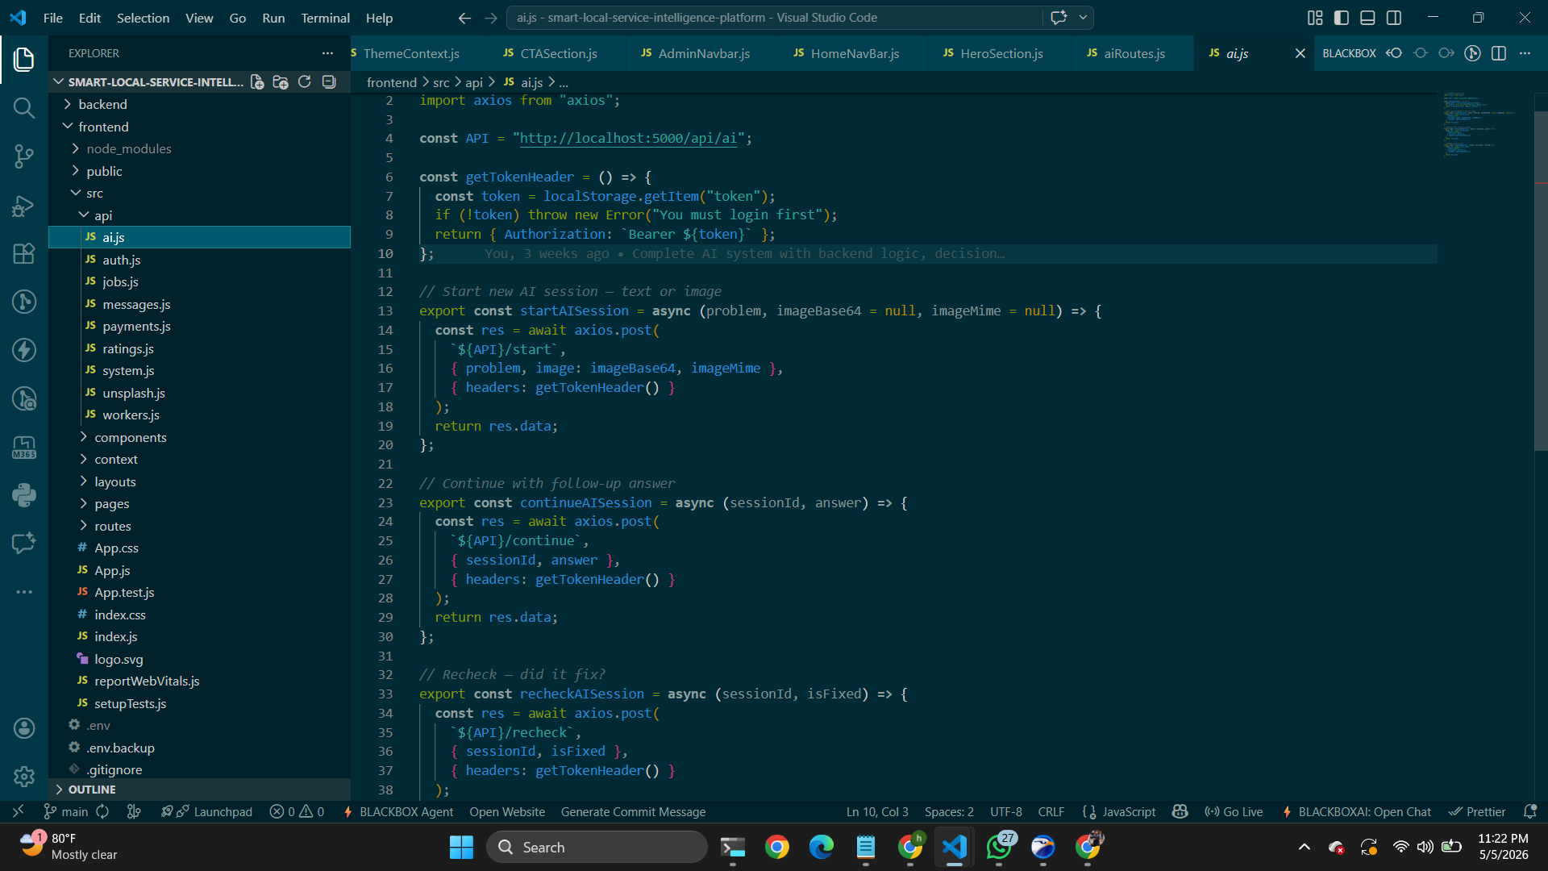

Customer dashboard 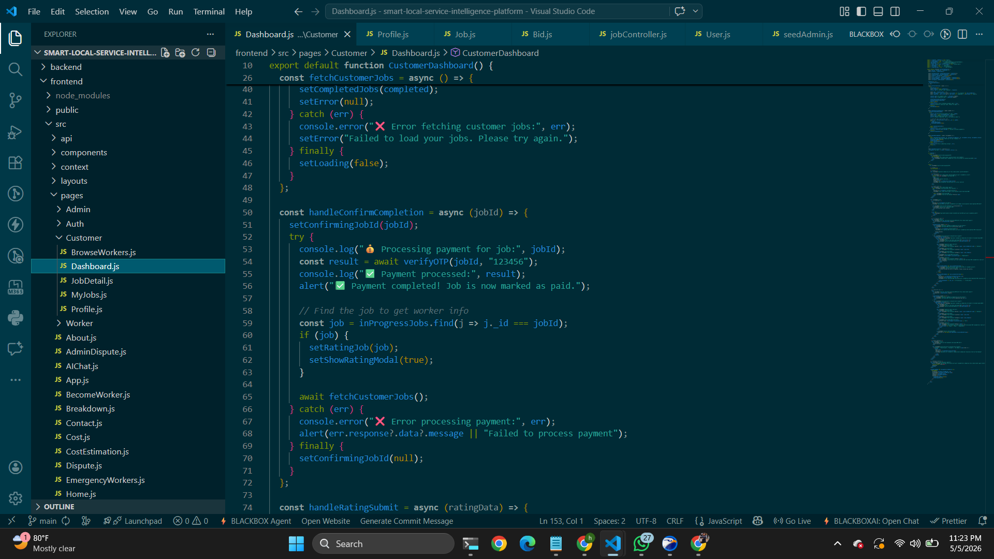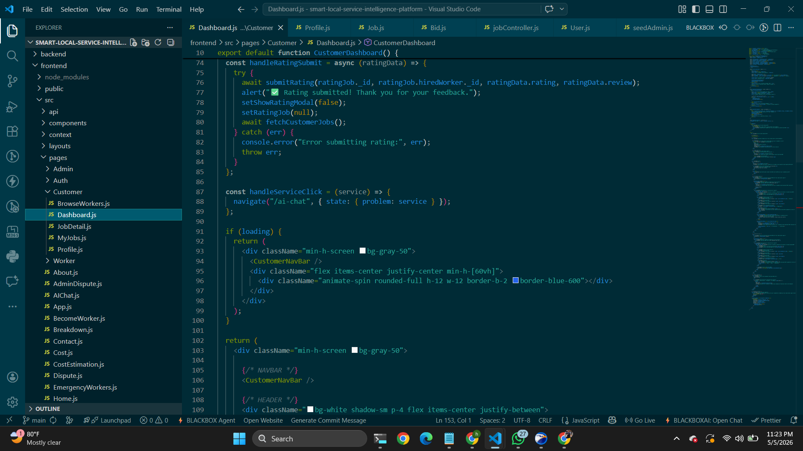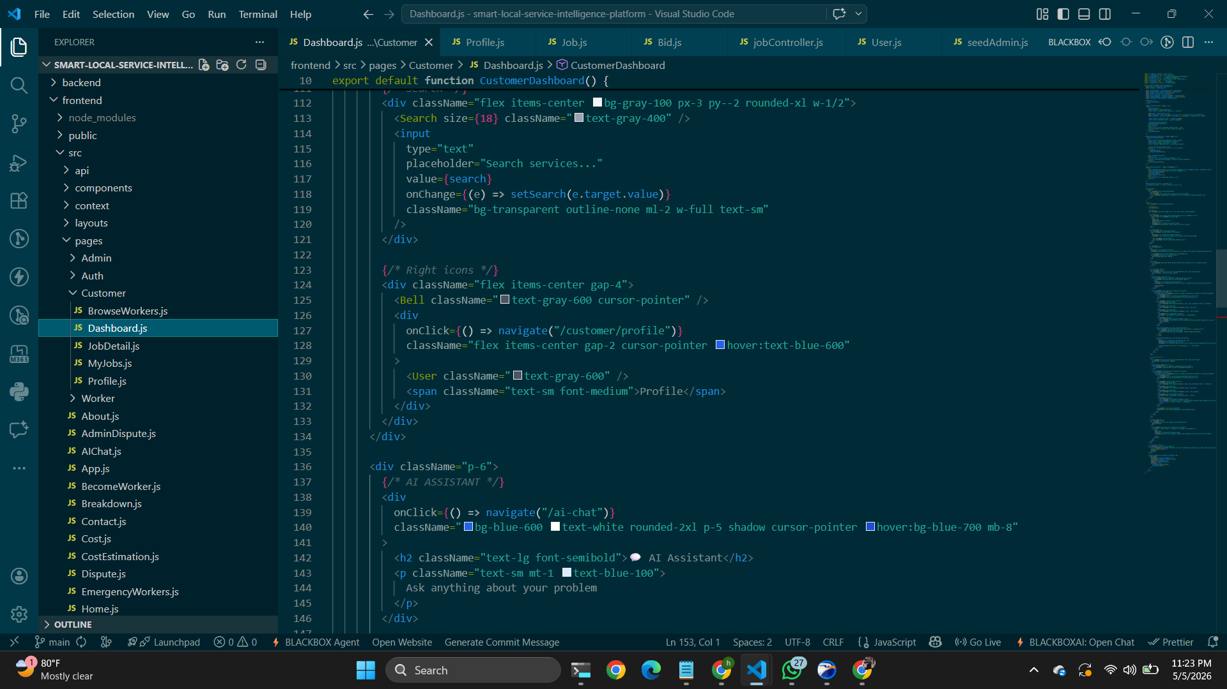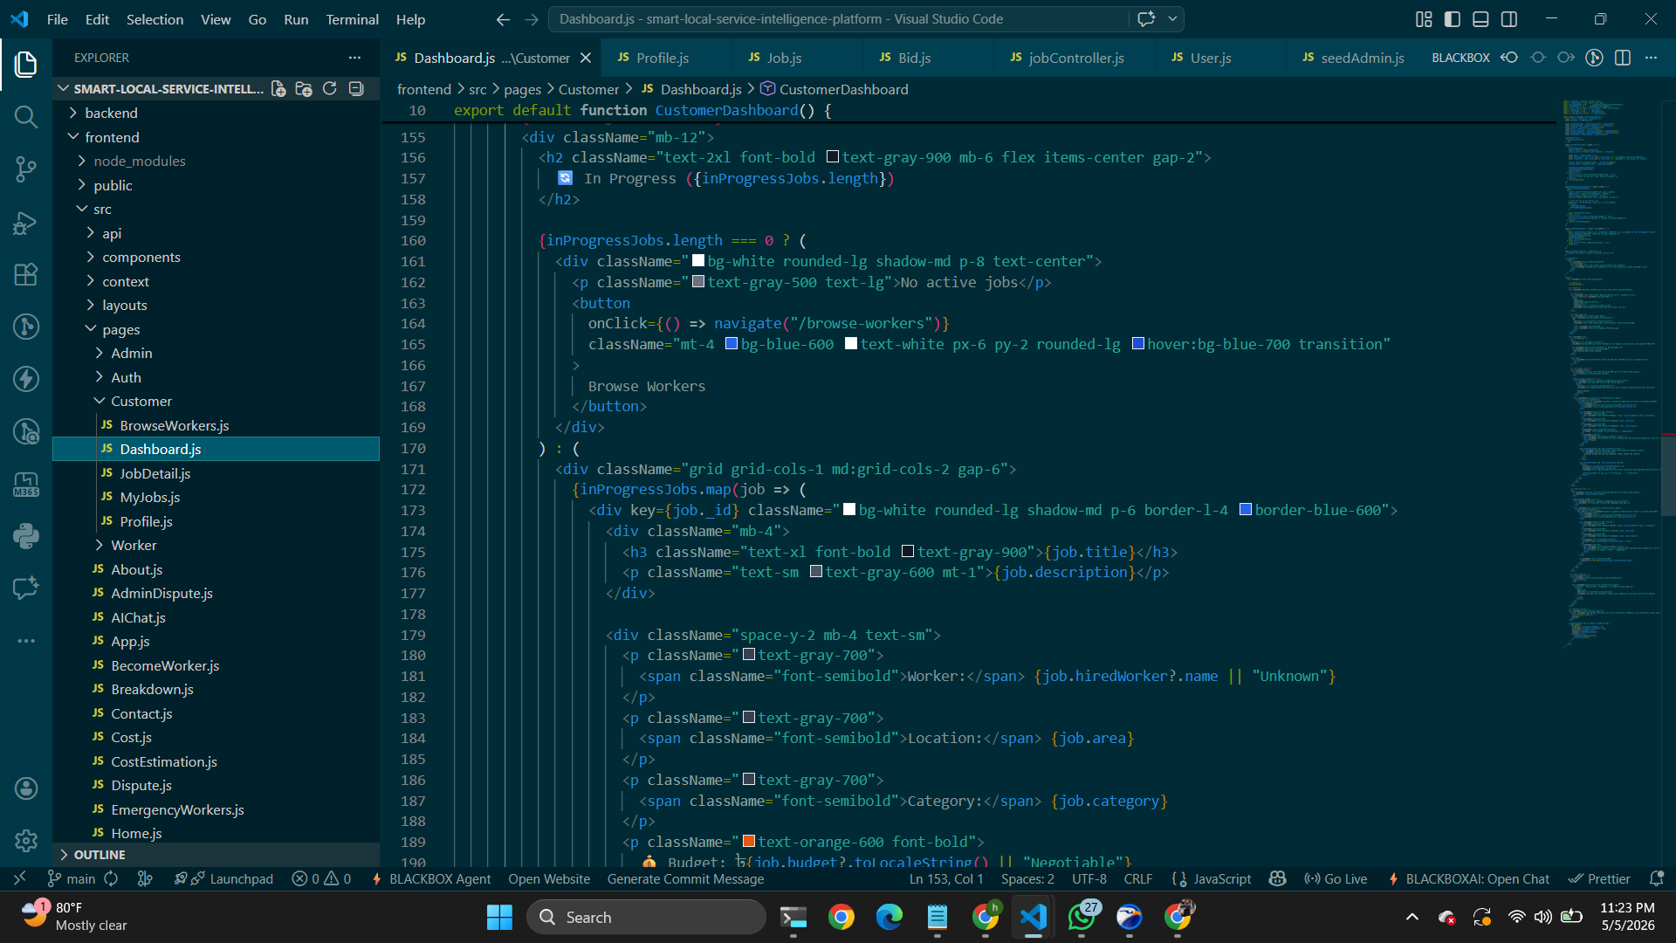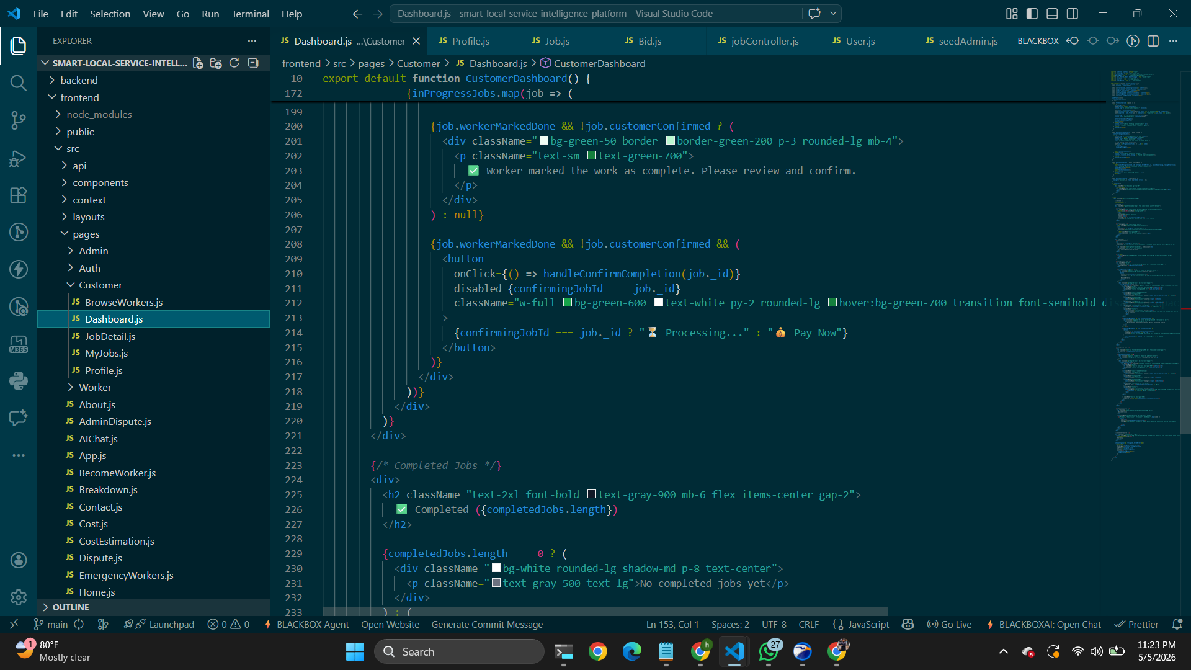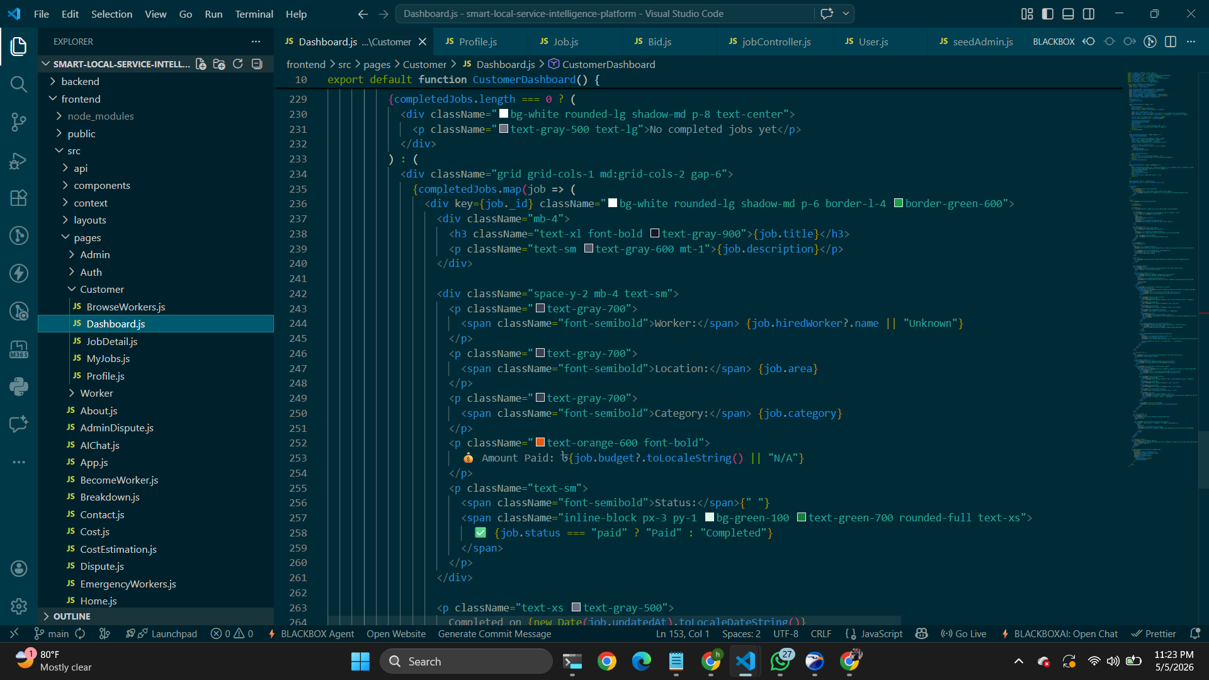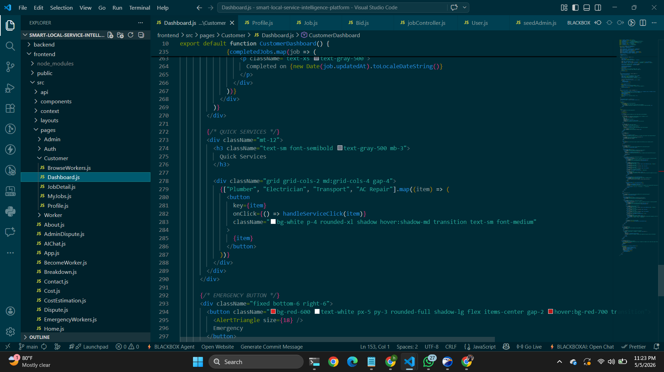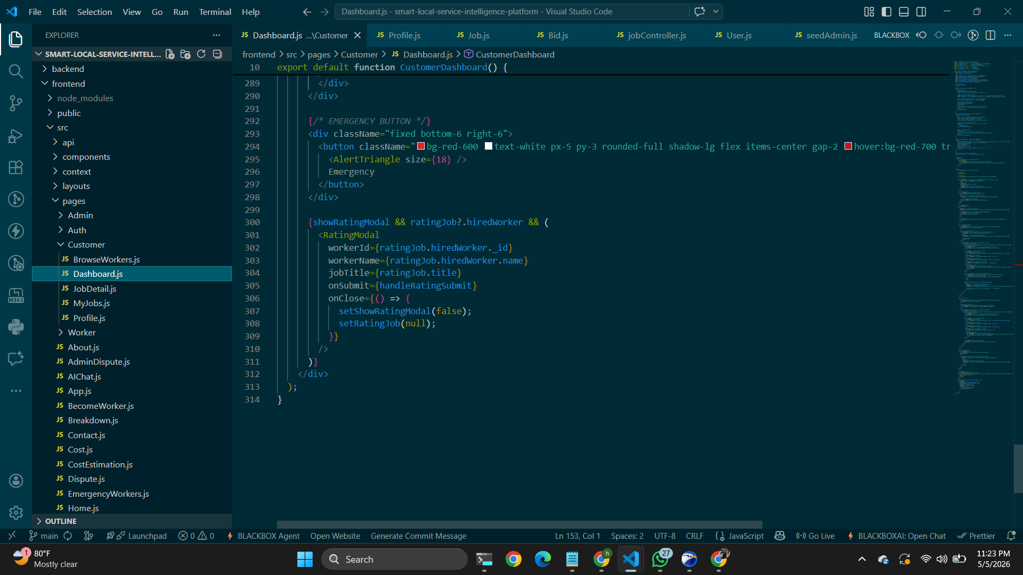

Ai chat page 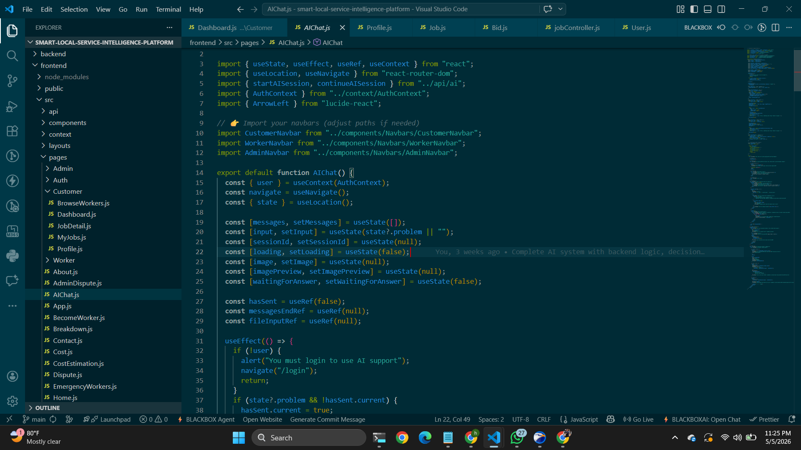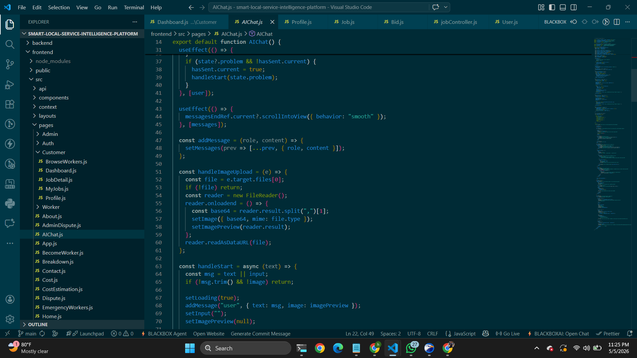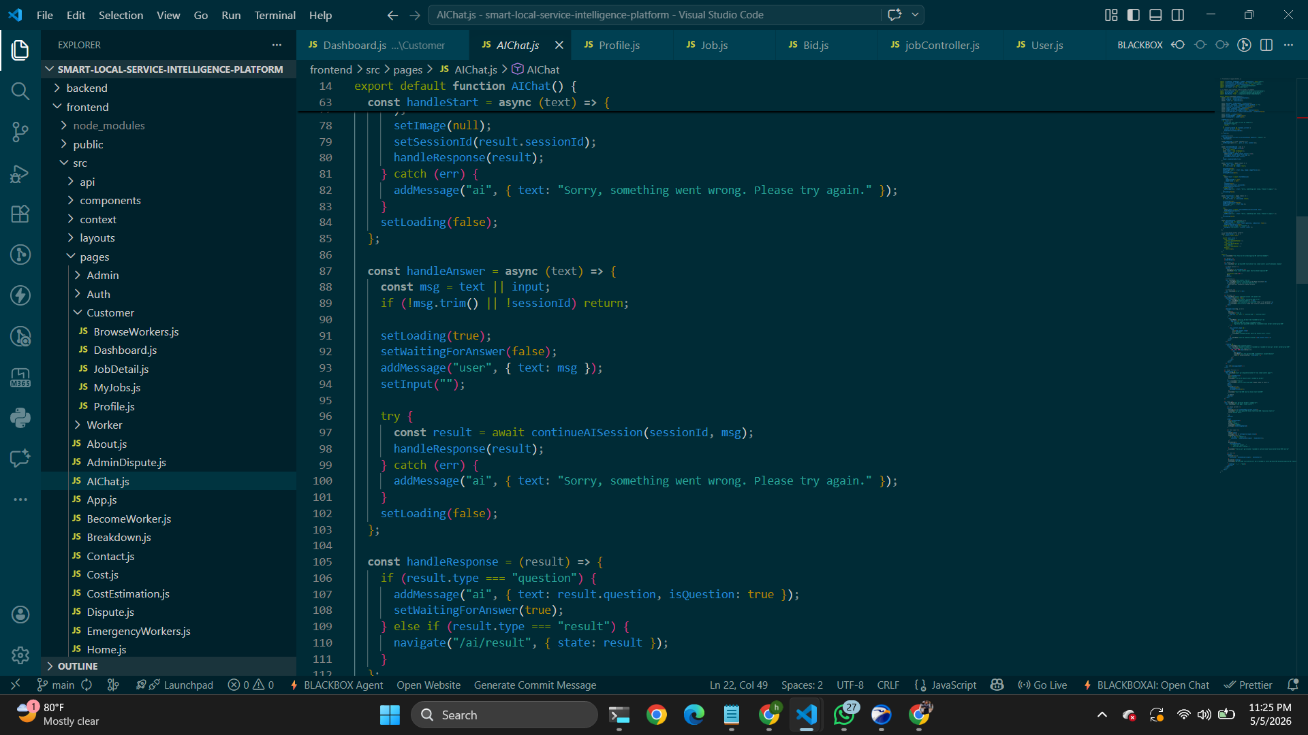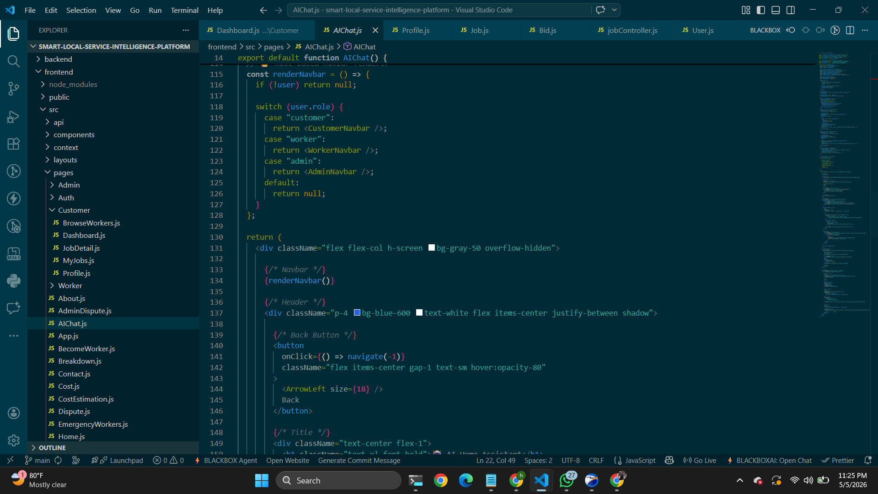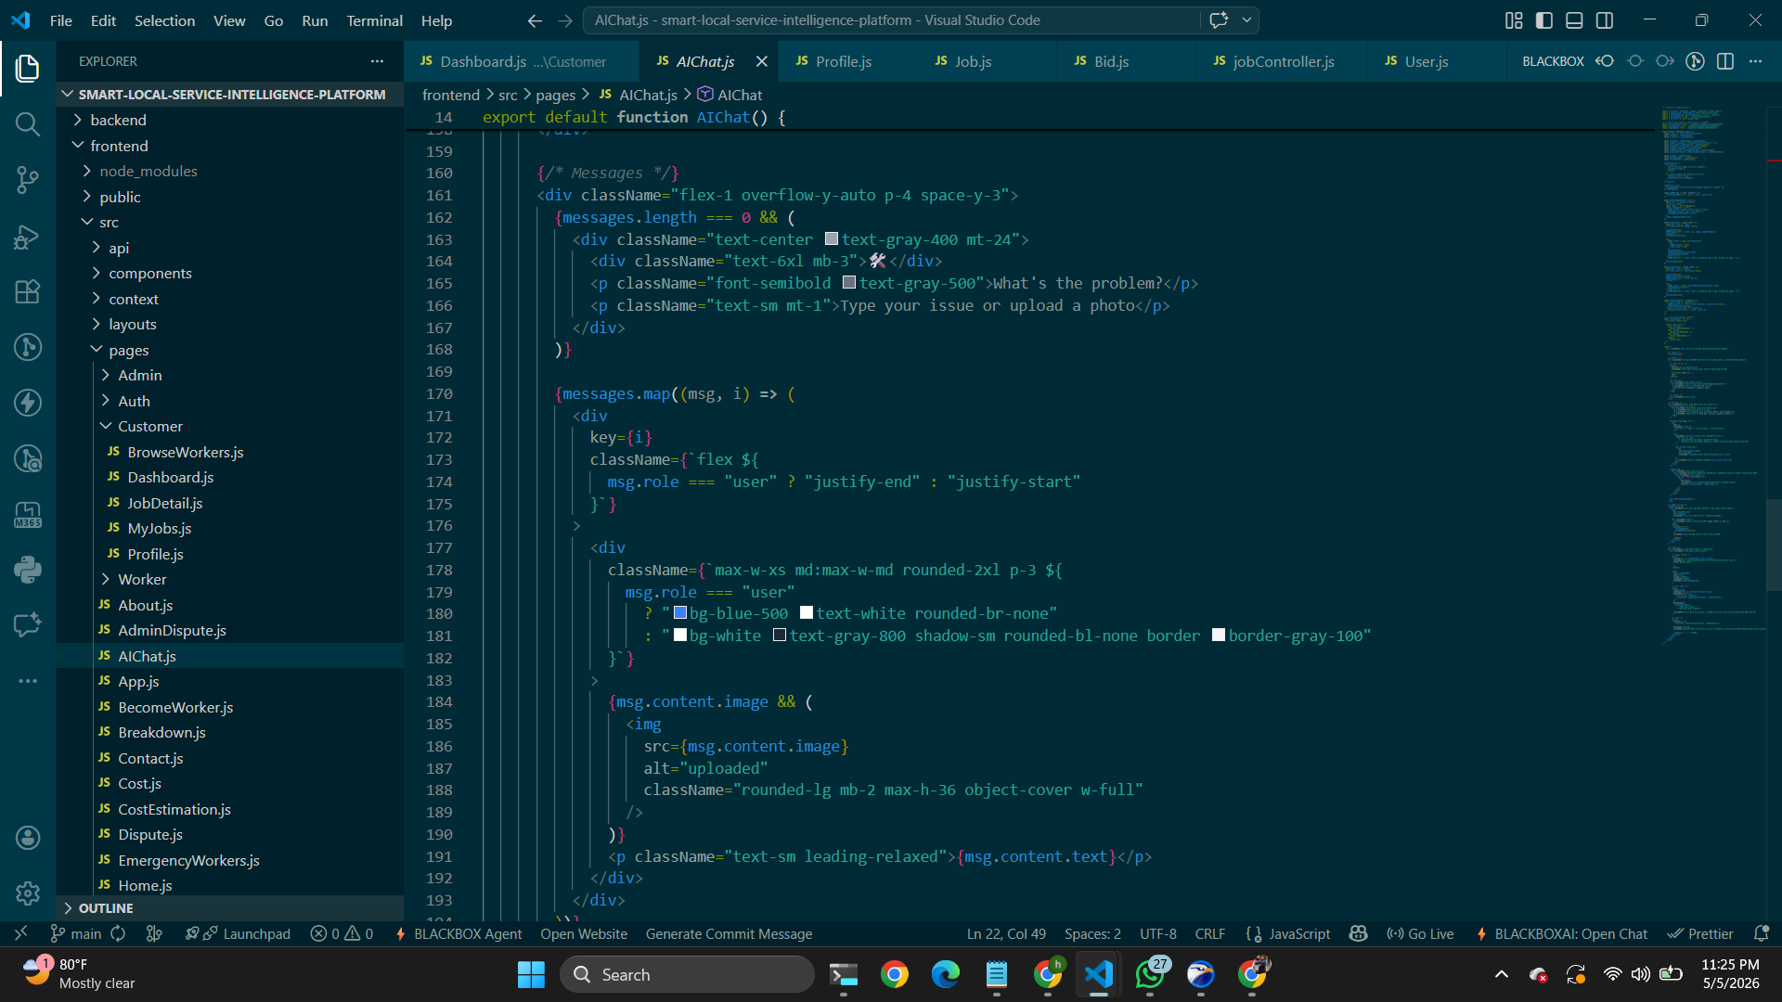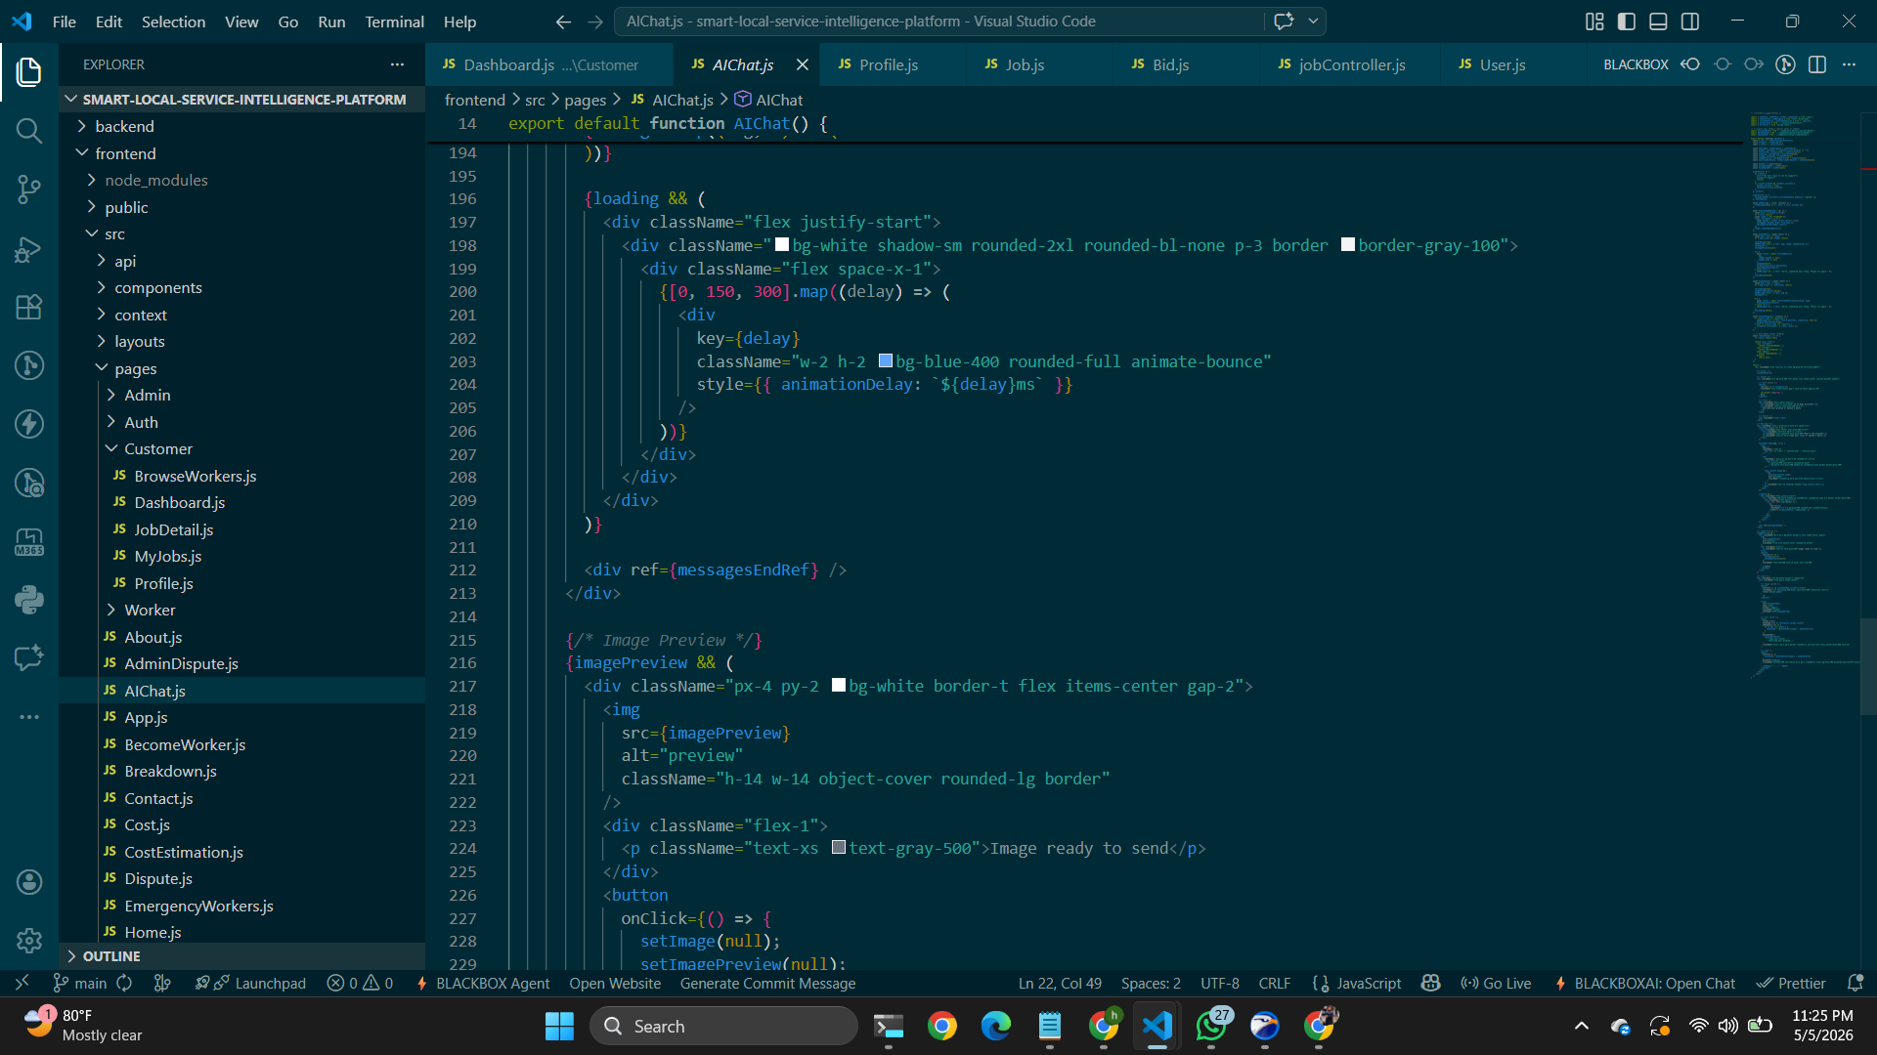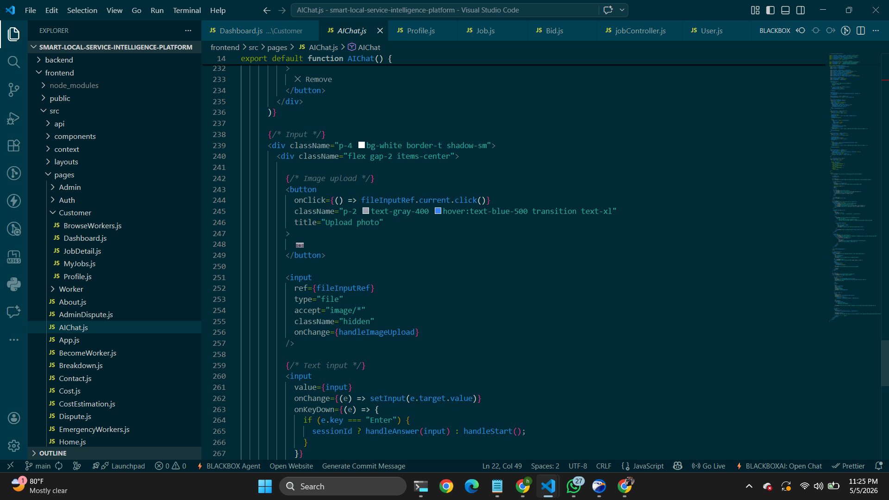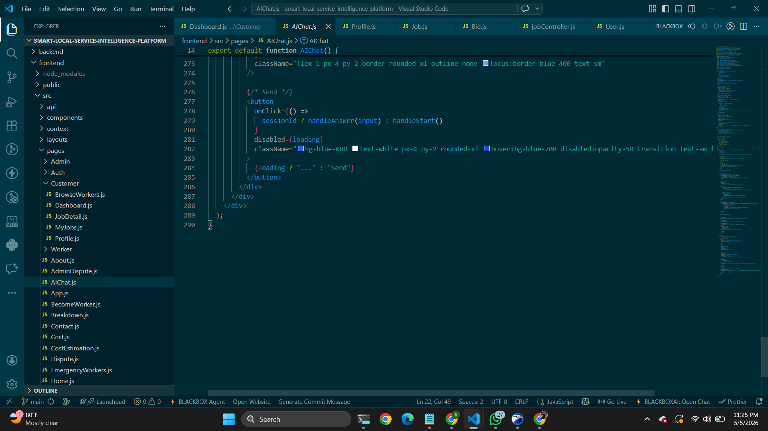

Ai Result page 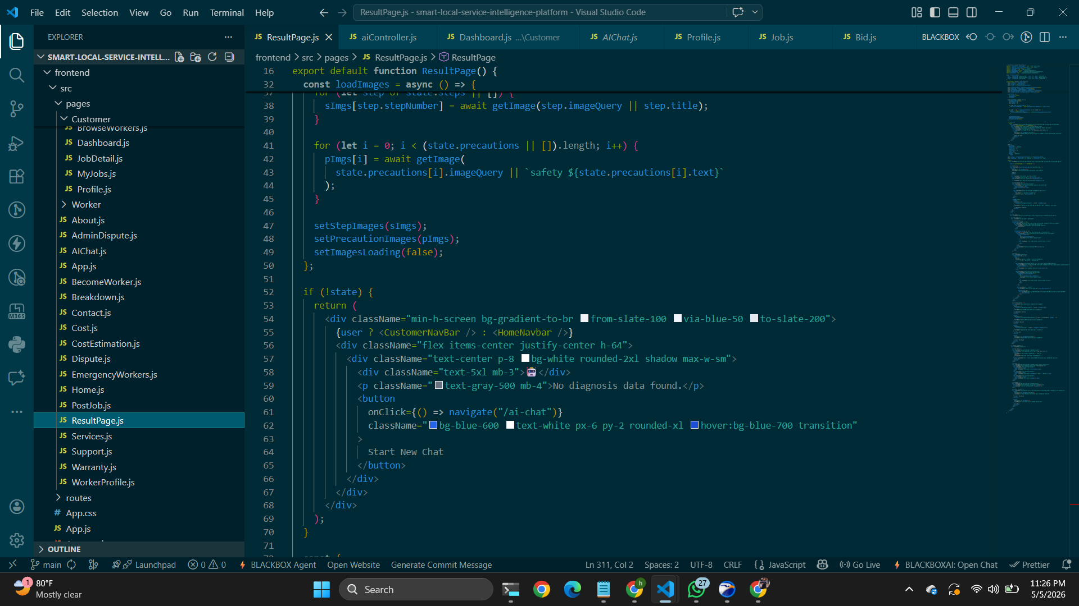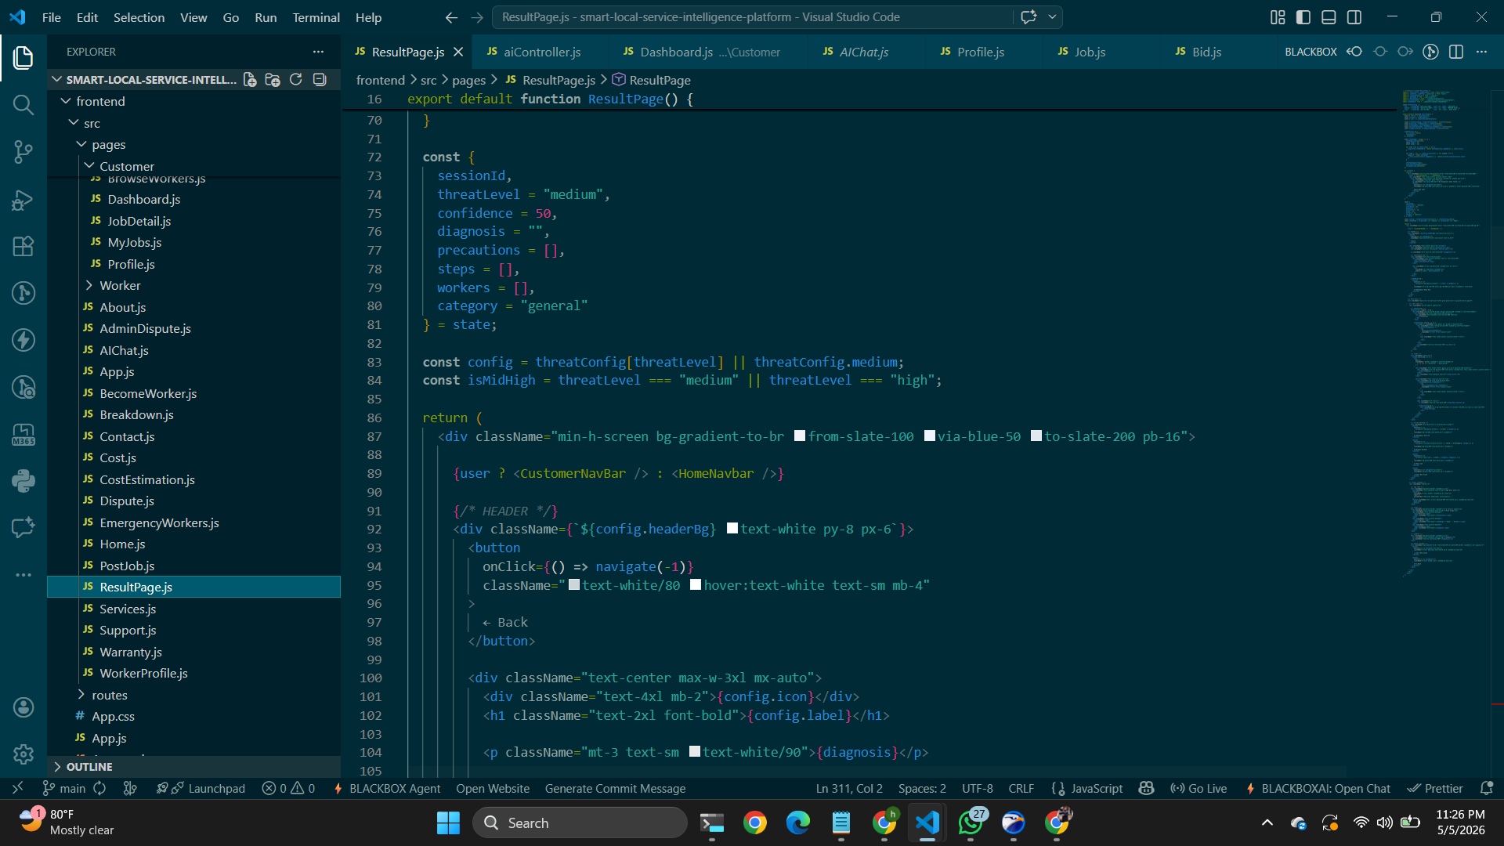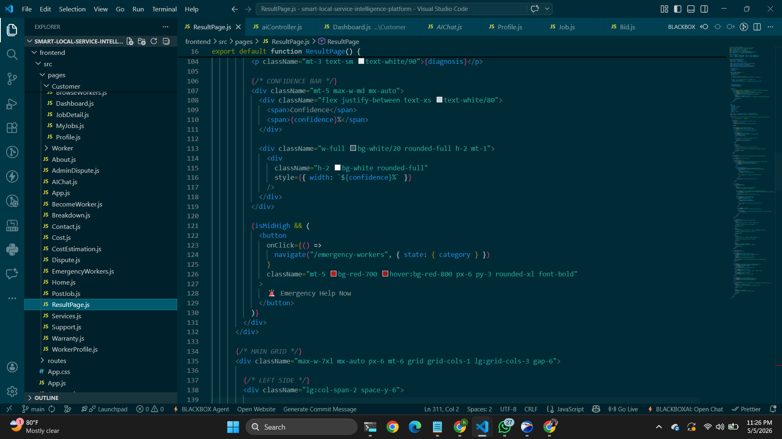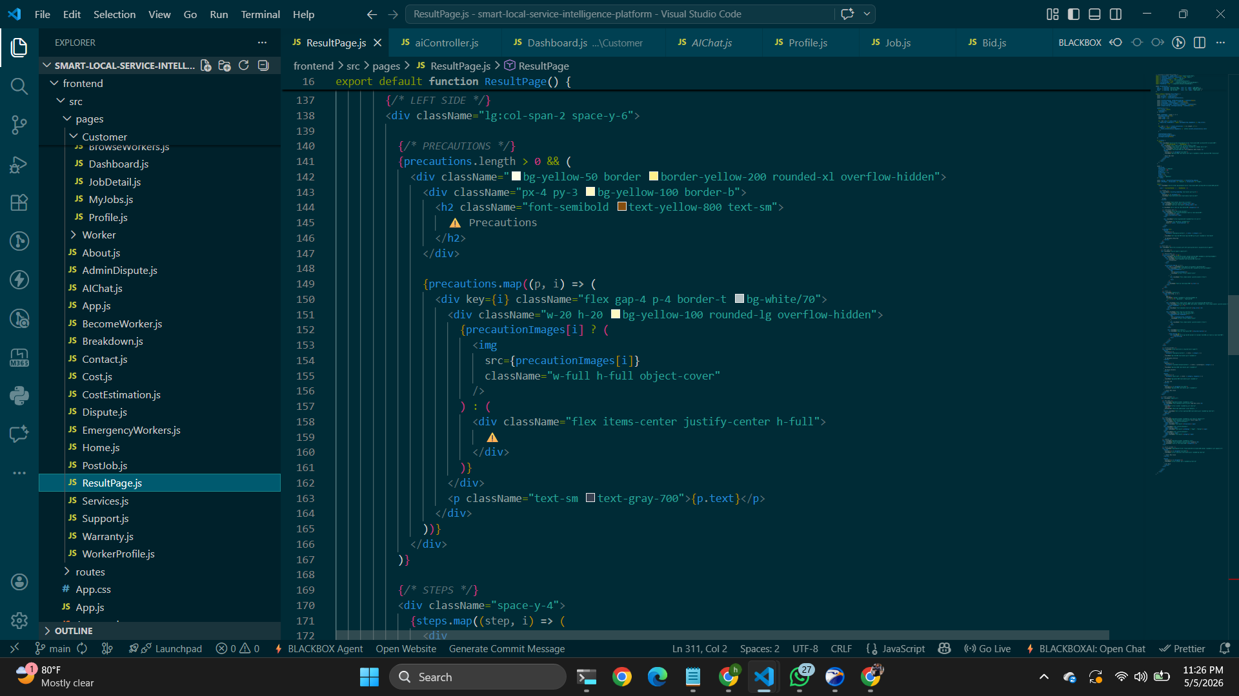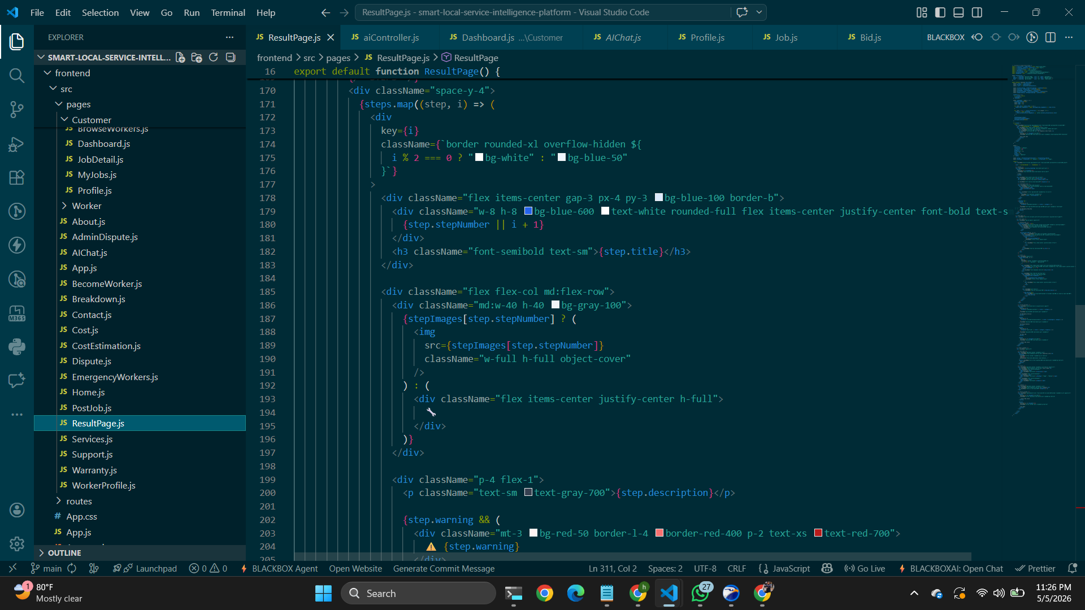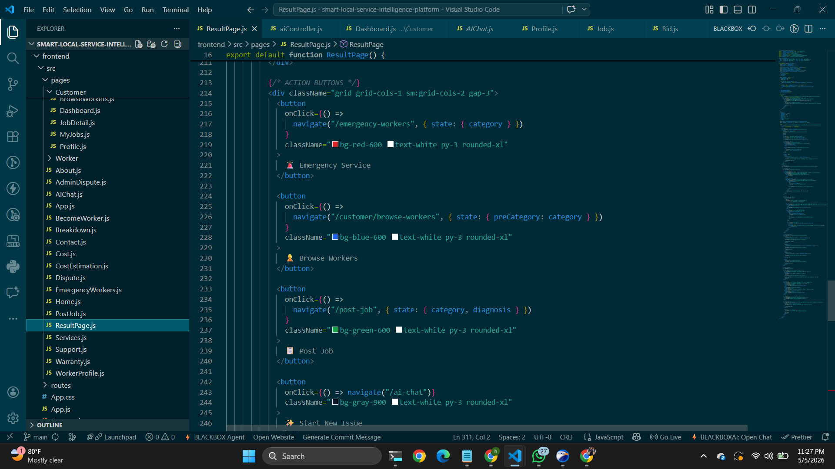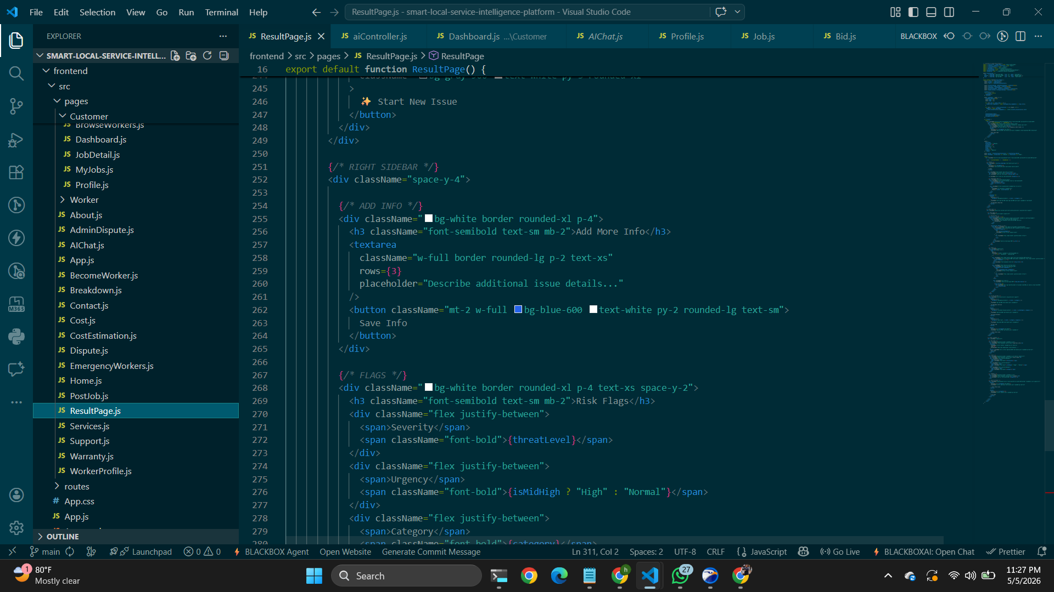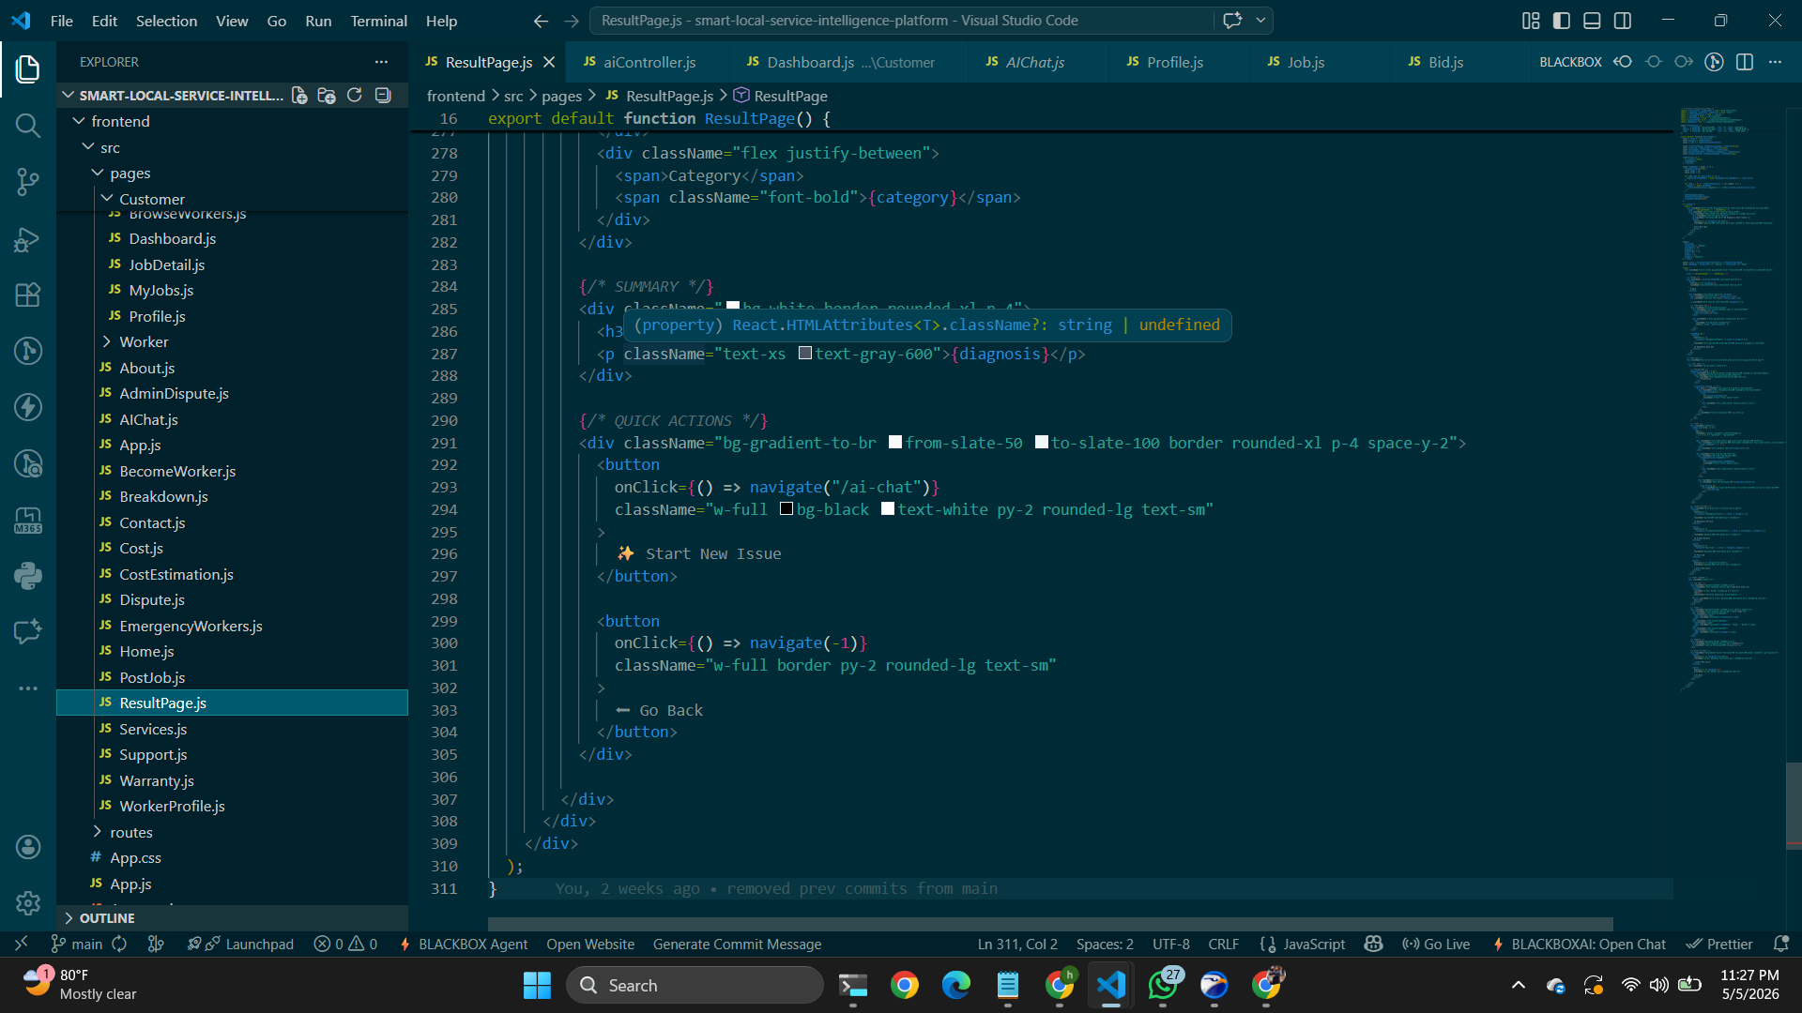

Ai section 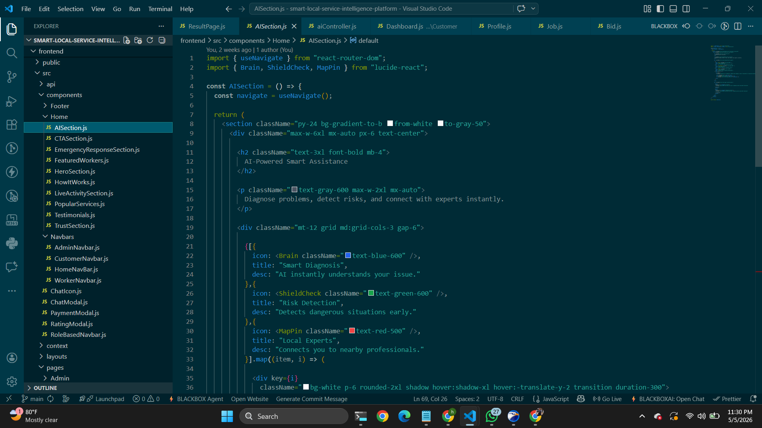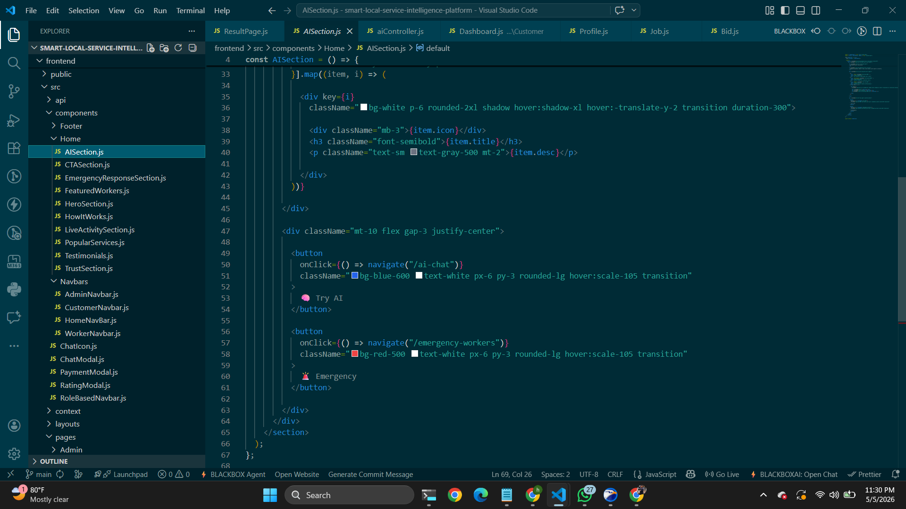
7. User Manual
How a new user will navigate or use the system with screenshots.
[Deema]1)User Registration-The user opens the platform and clicks Sign Up
The user enters name, email, password.
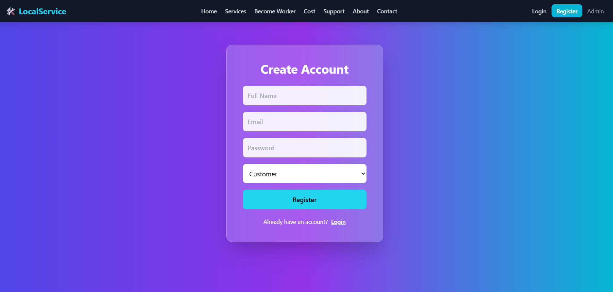

2)Login:User logs into the system using credentials
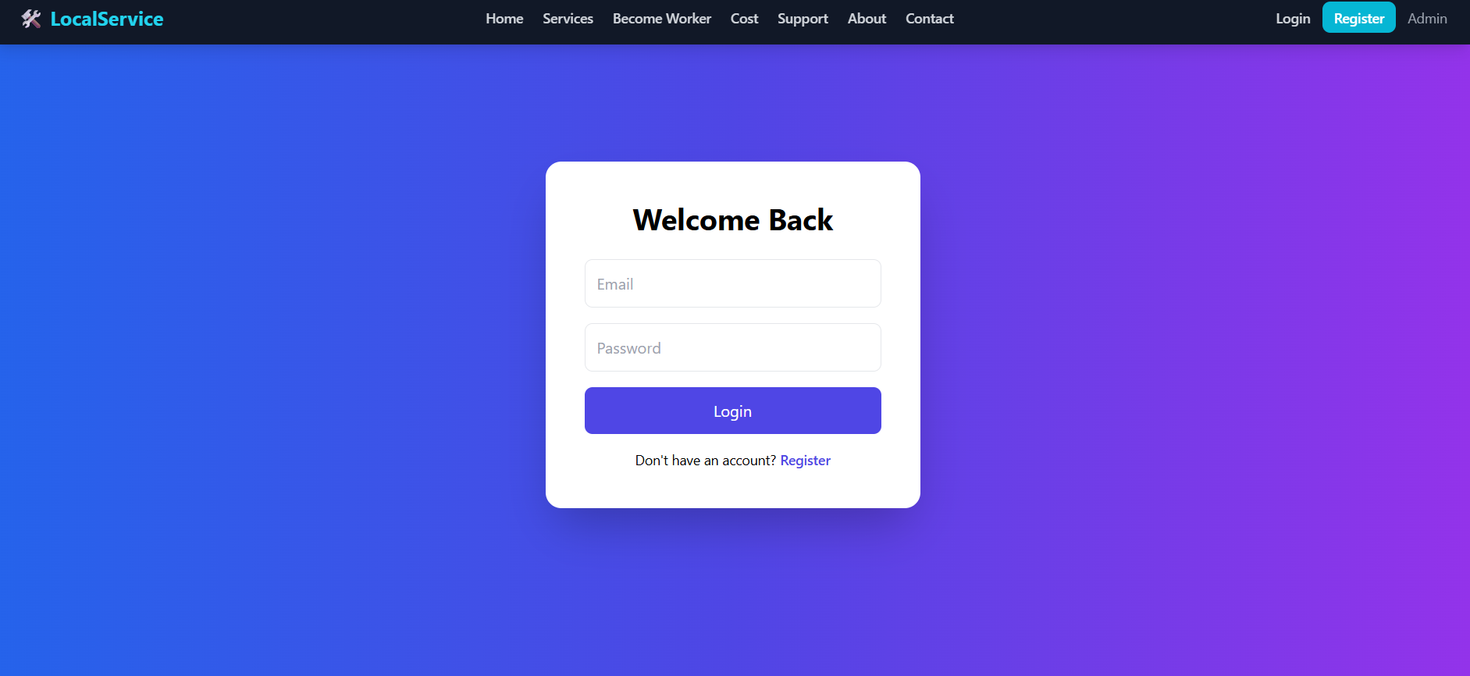
3)View Cost Estimation-User clicks Cost button,System shows estimated cost
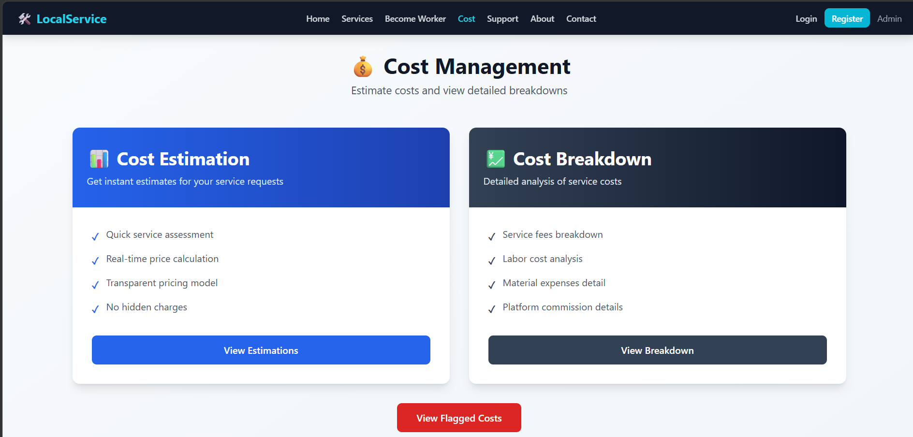
4)Warranty Page-User navigates to Support → Warranty,Warranty details are displayed
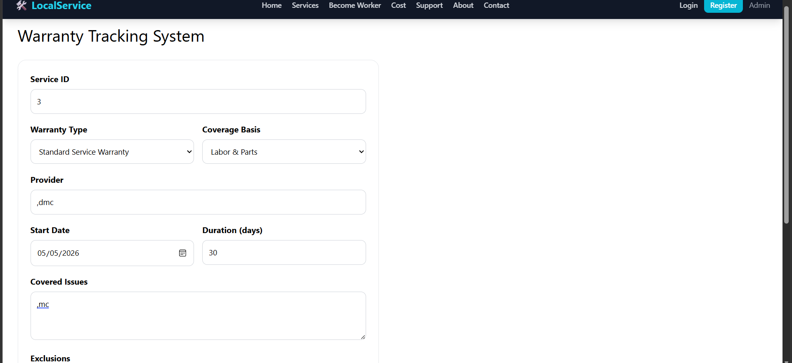
5)Submit Dispute-User opens dispute page,Fills form and uploads files
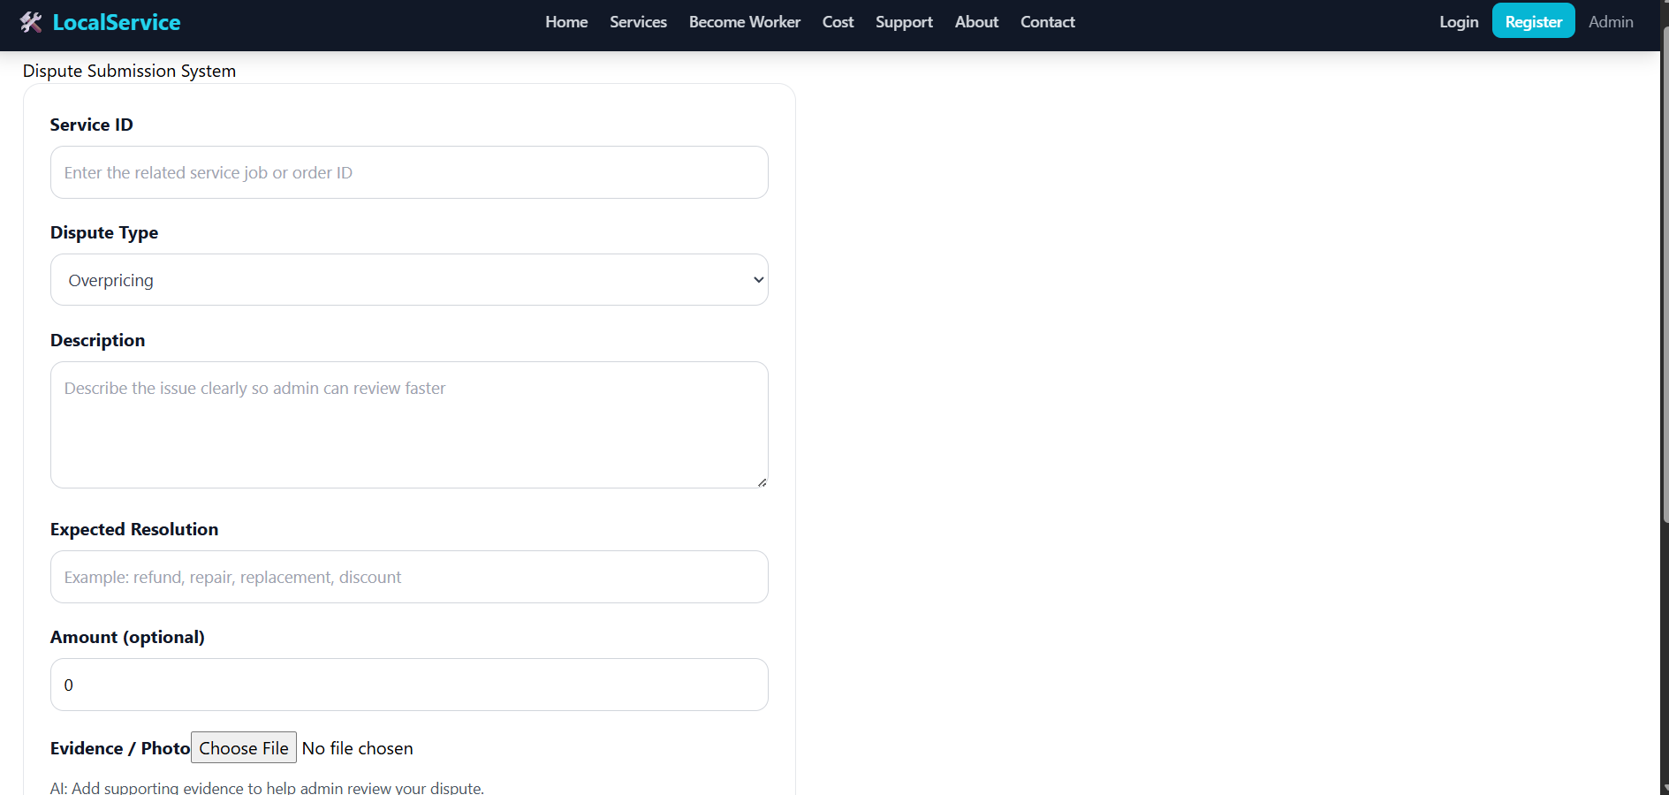

FARHAN :
1.Browse Workers: customers can have a dedicated worker browsing page.
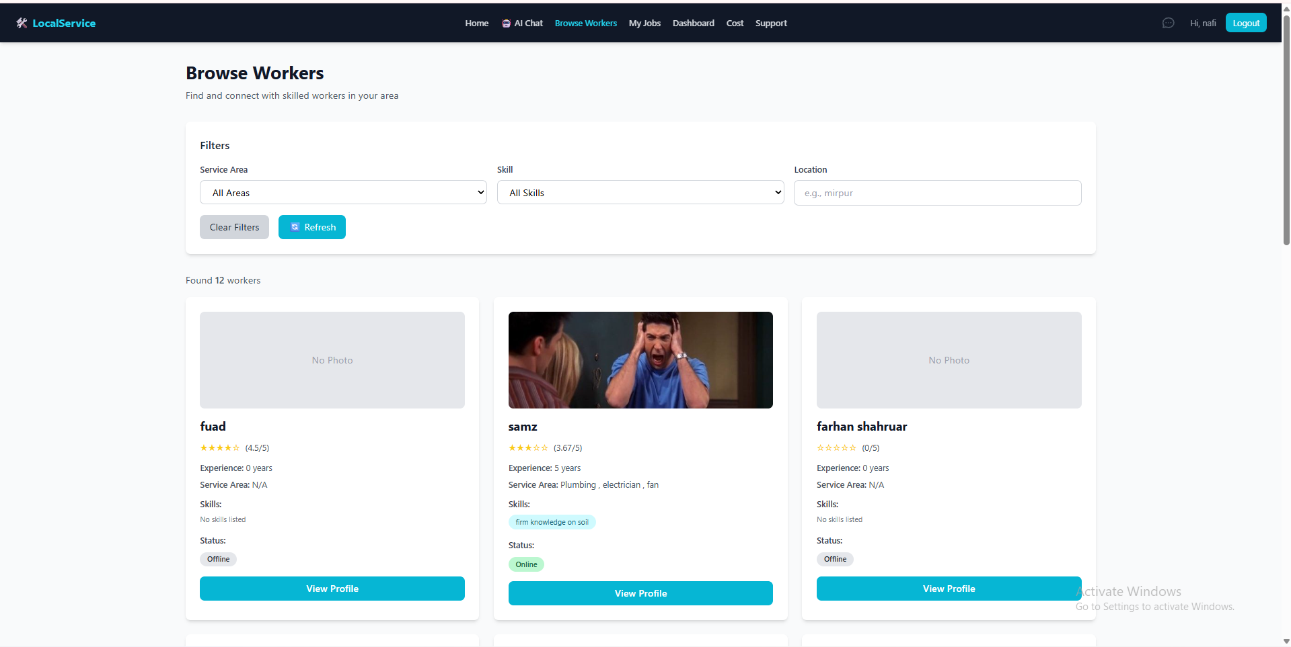
2. Chat System: The system has a messaging option among workers and customers.
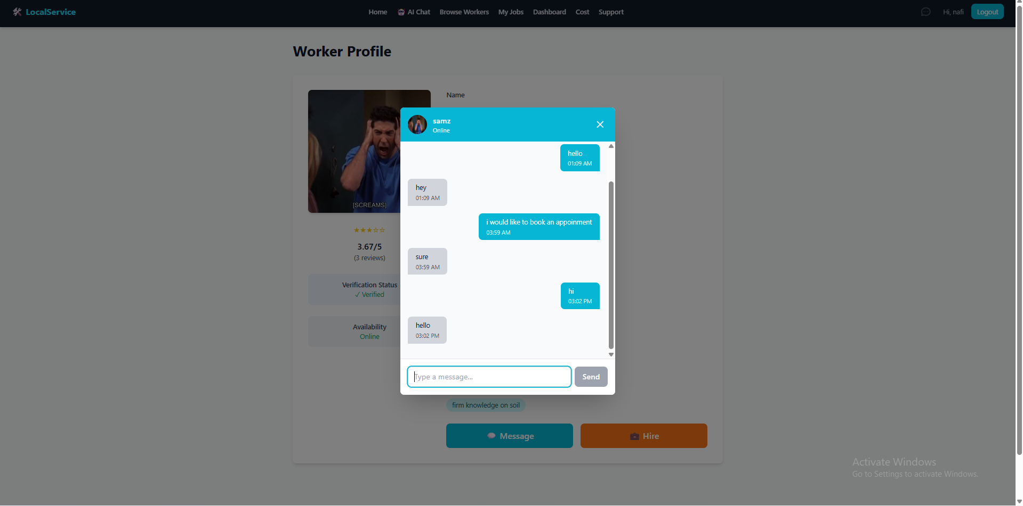

3.Worker profile page: workers have a dedicated profile section.
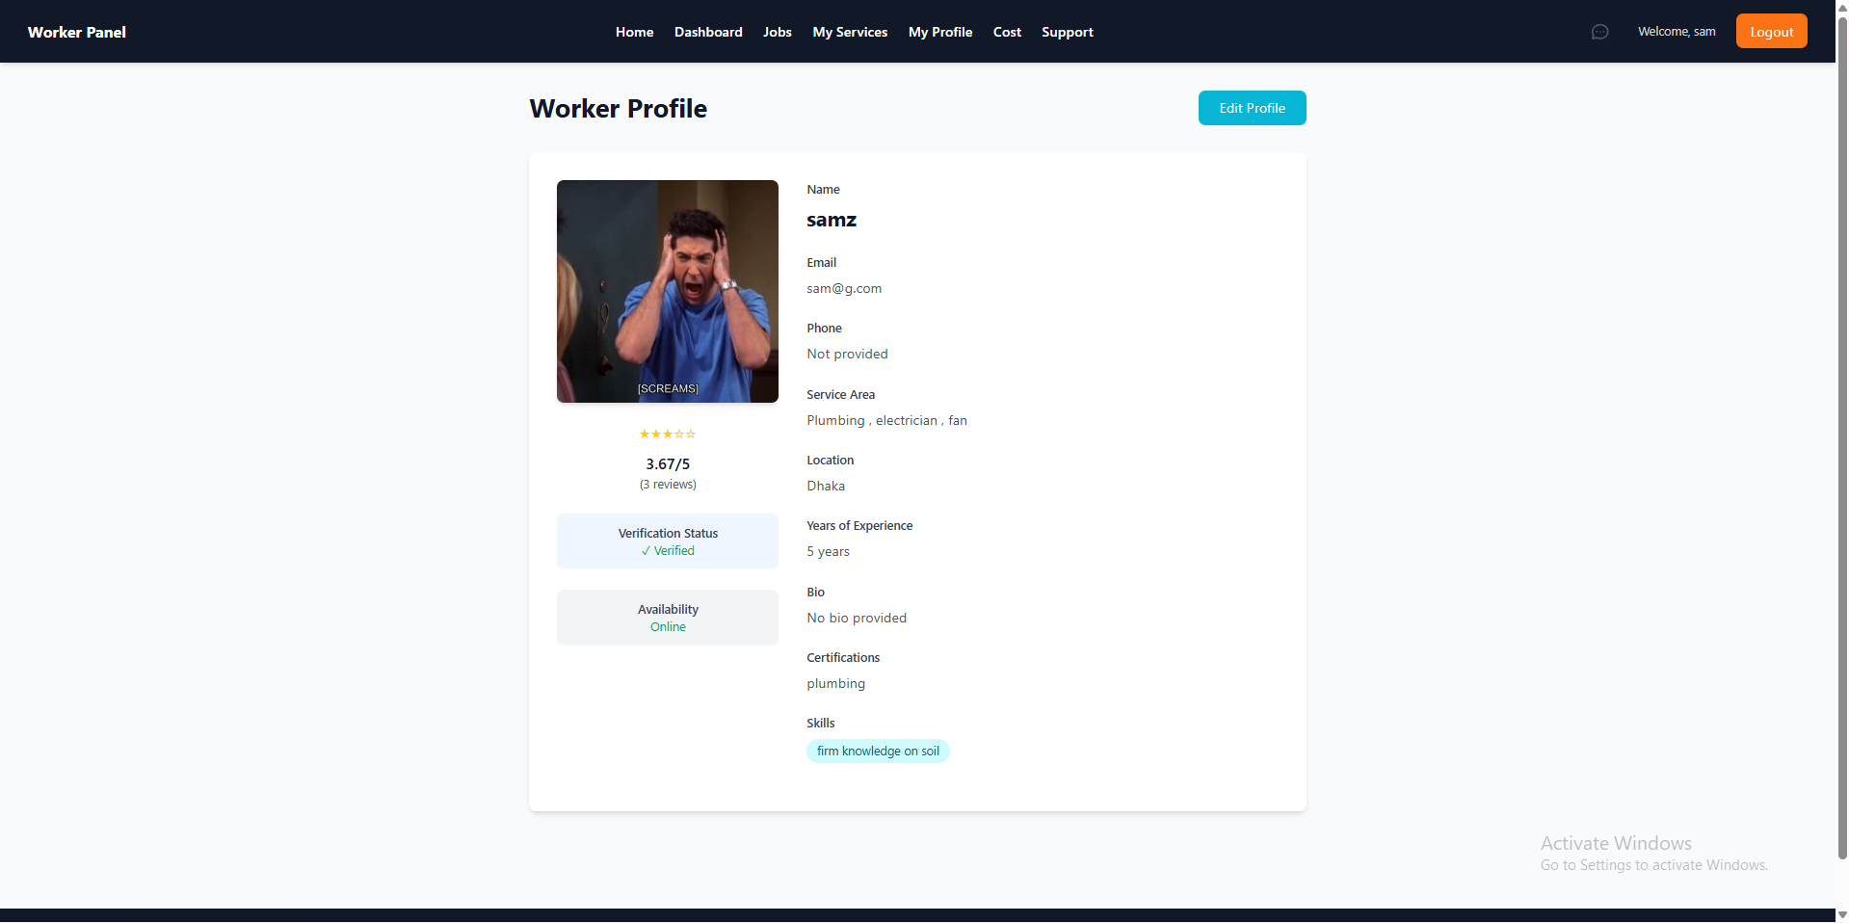
4. Edit profile functionality: workers can edit their profile, change their availability status, location, images etc.
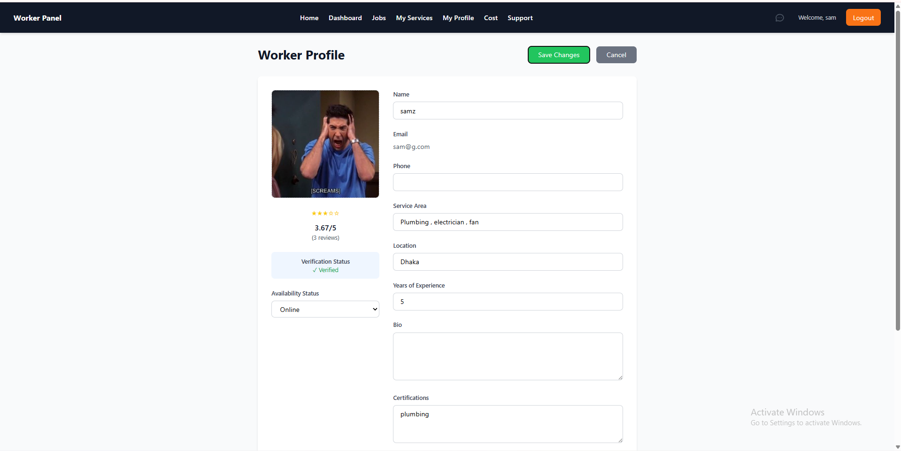

5. Post Job: as a customer you can post jobs and hire workers according to your needs.
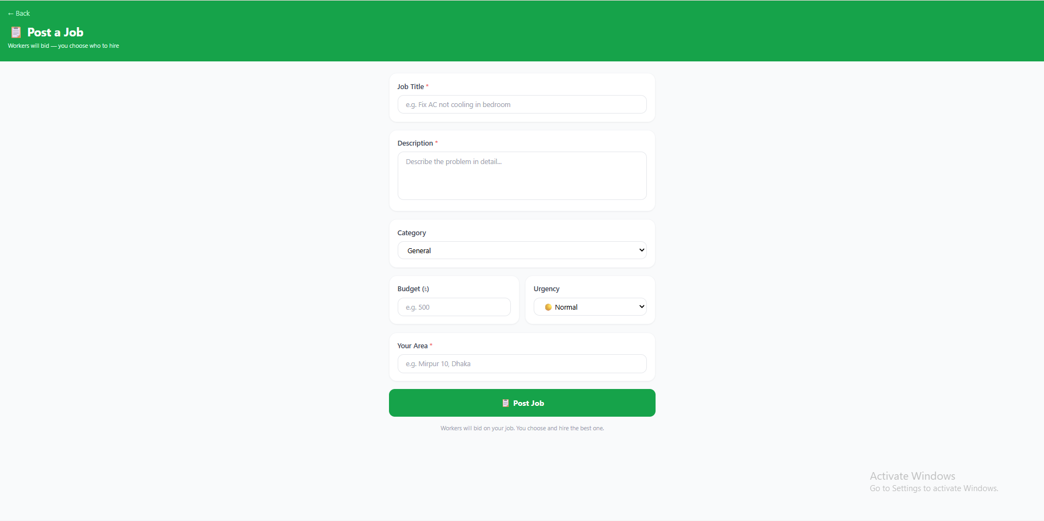

Saud:
Registered user can access ai support 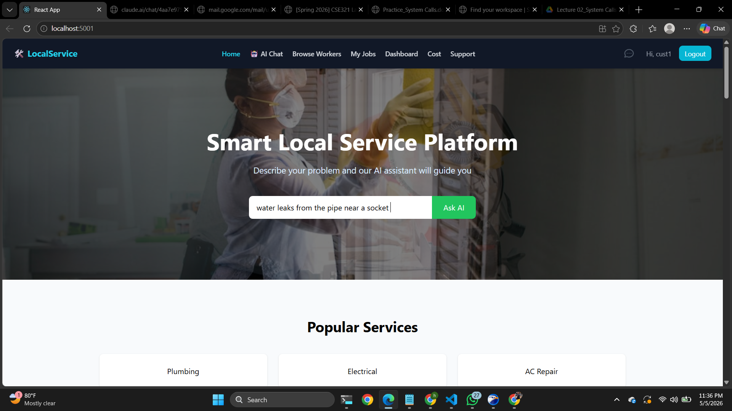

Ai support -
Upon clicking on ask ai it leads to ai chat page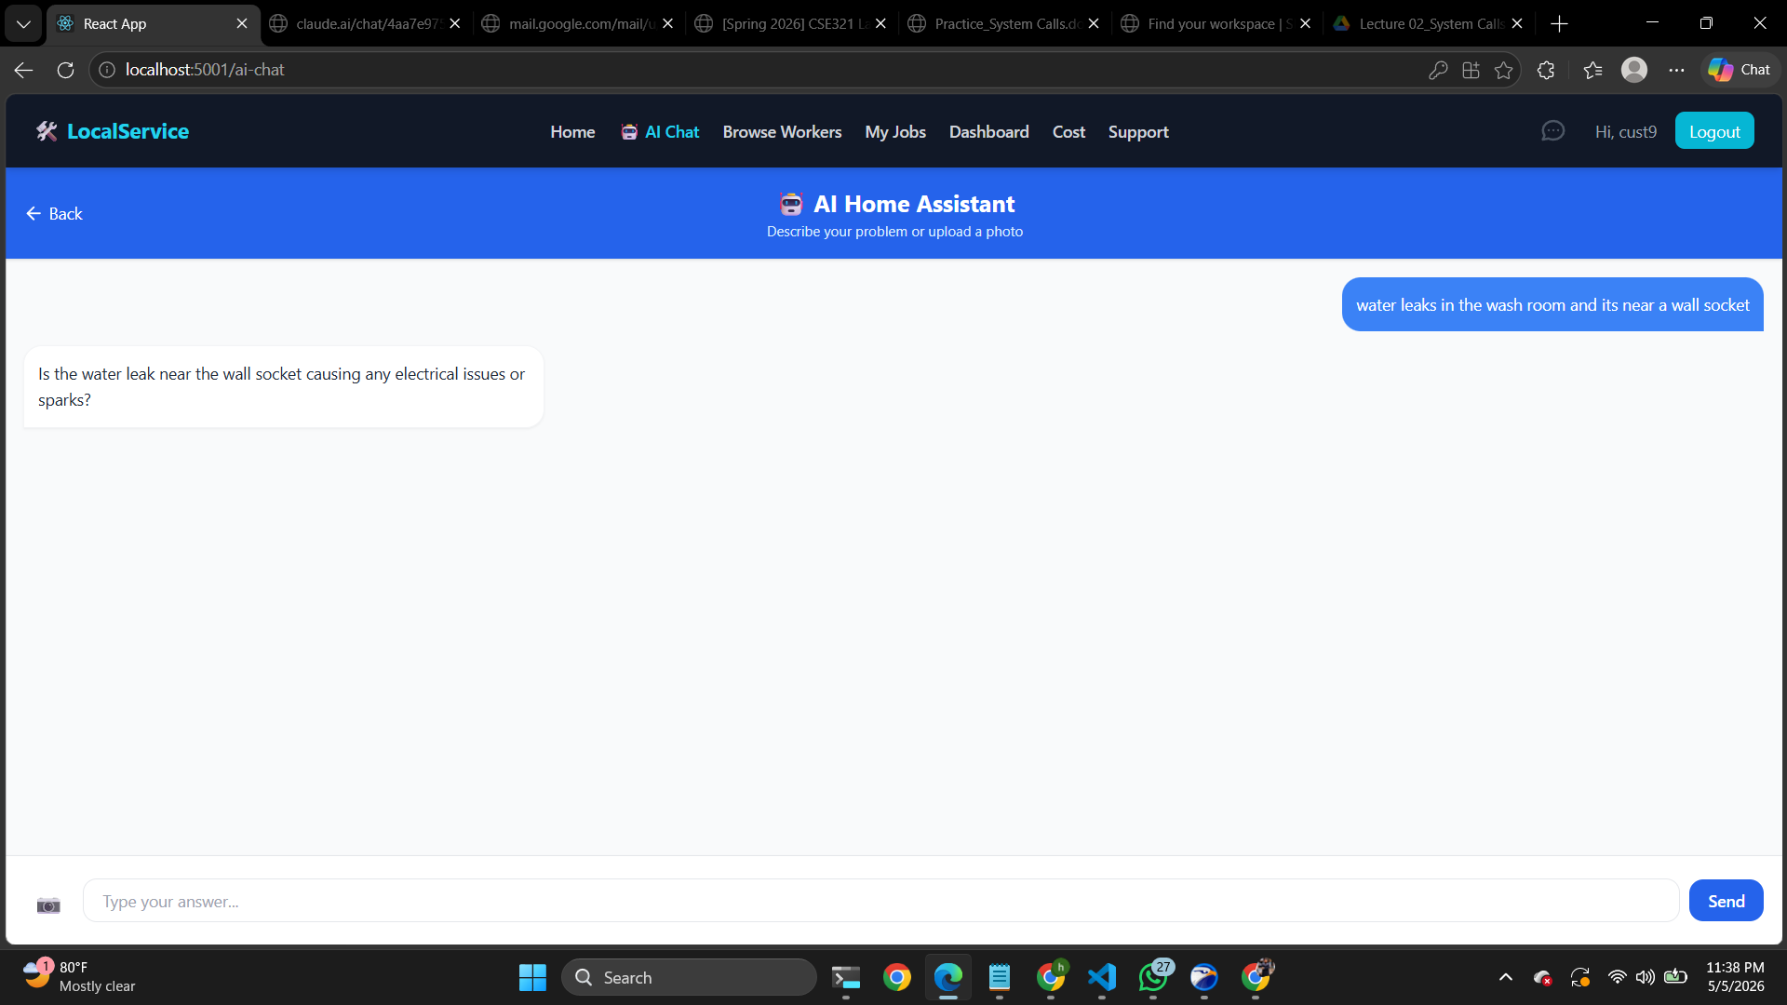

Result Page:
Ask questions and eventually lead to results page
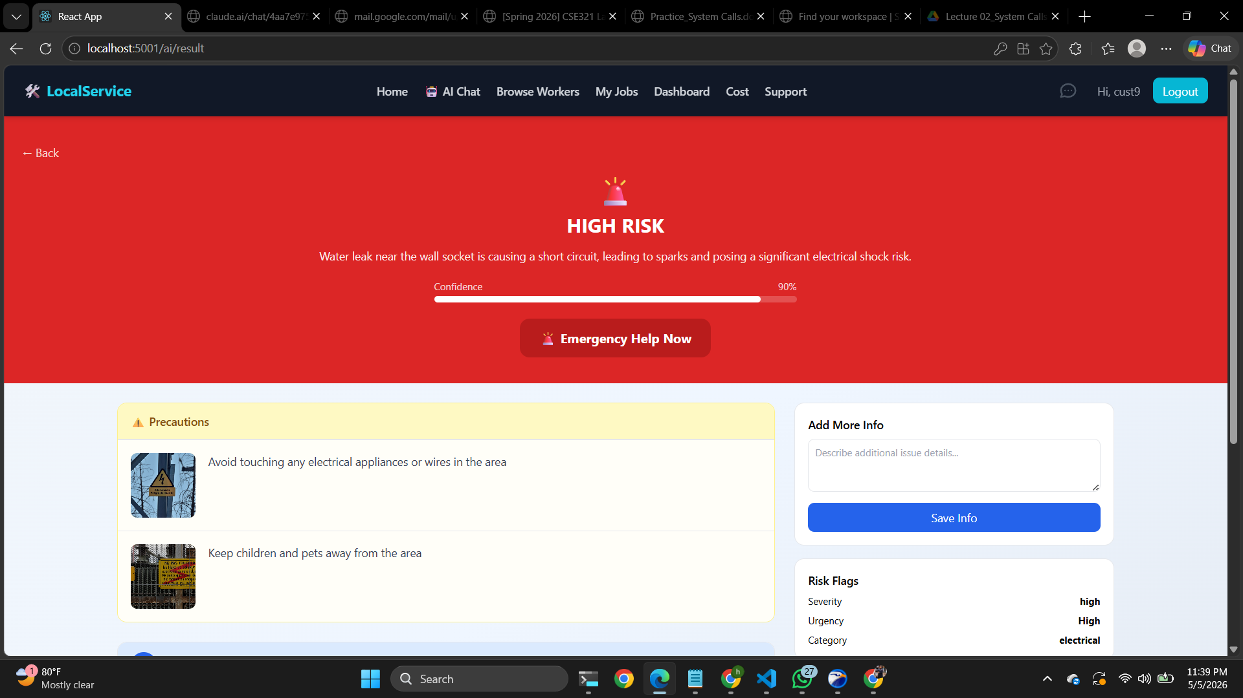

Analyze from images and give precautions and solutions also give direction to solve the problem
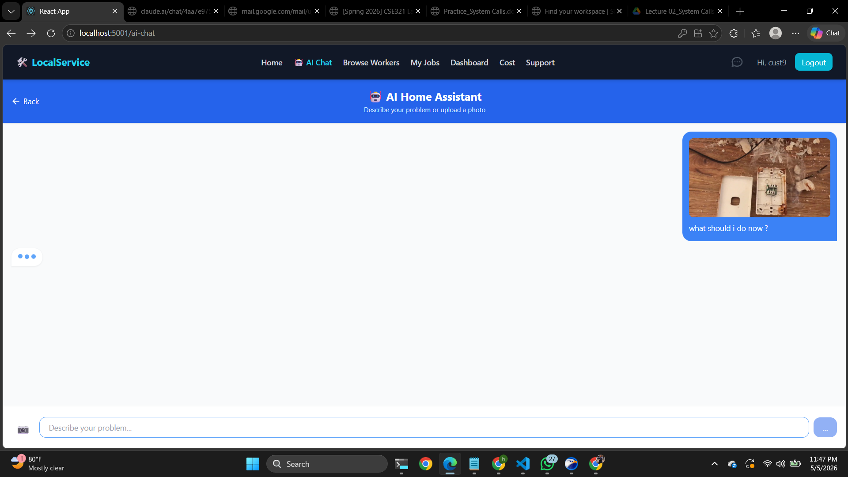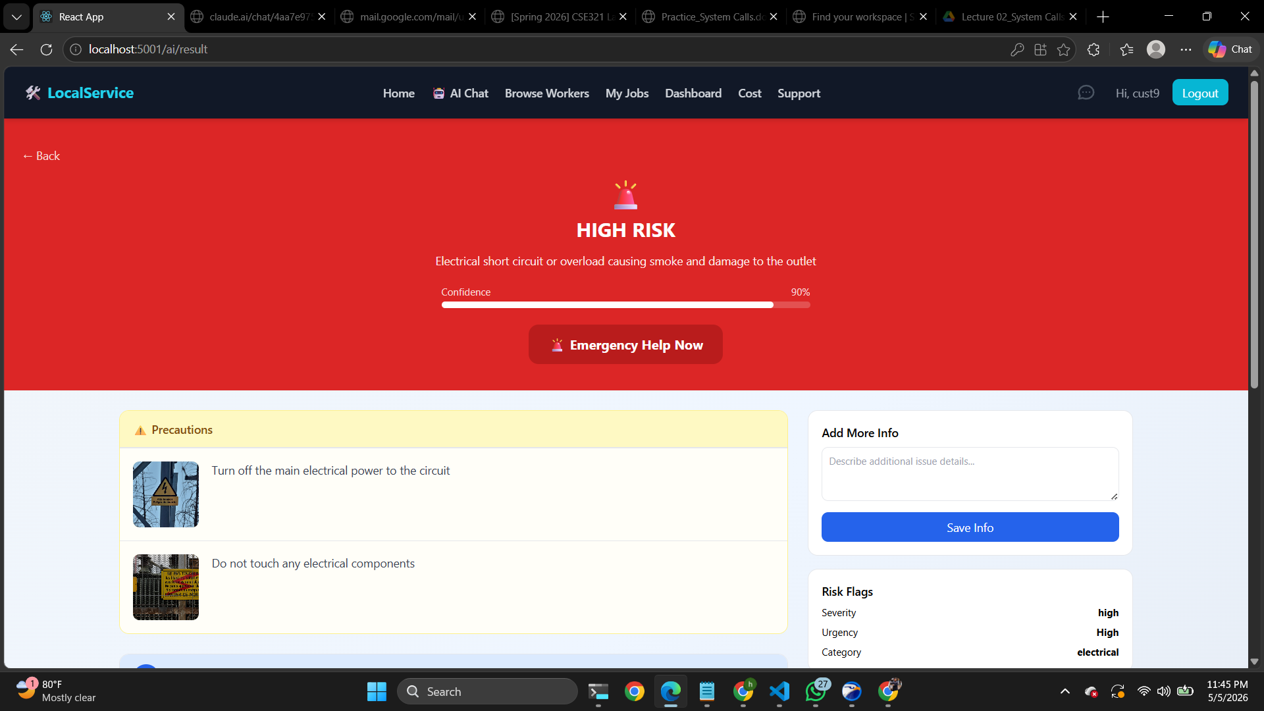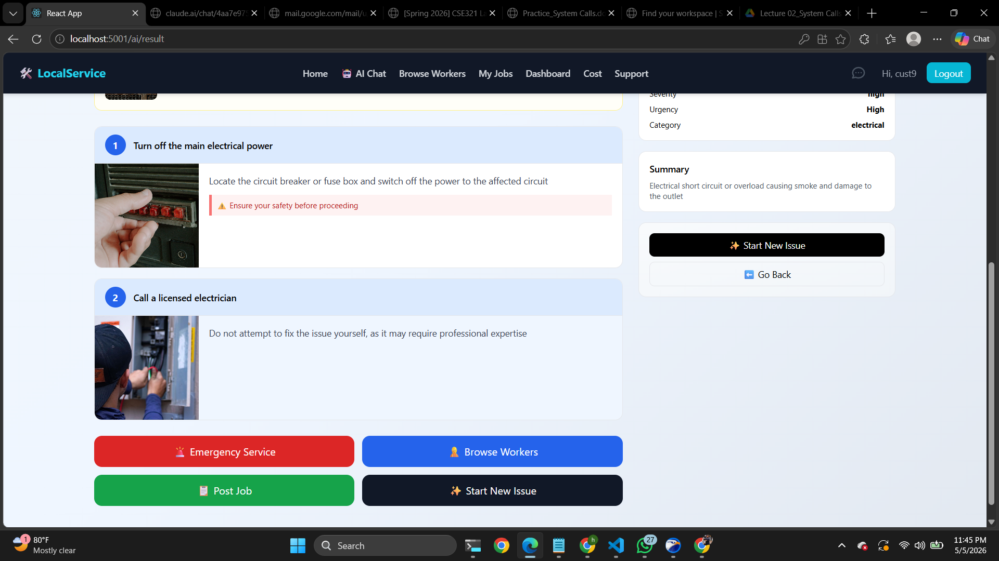

8. Performance and Network Analysis
Generate Performance and Network analysis report using lighthouse DevTool. Add screenshots of the report. Also, attach a screenshot of your system in any mobile viewport. The system UI must be responsive.
[Deema]
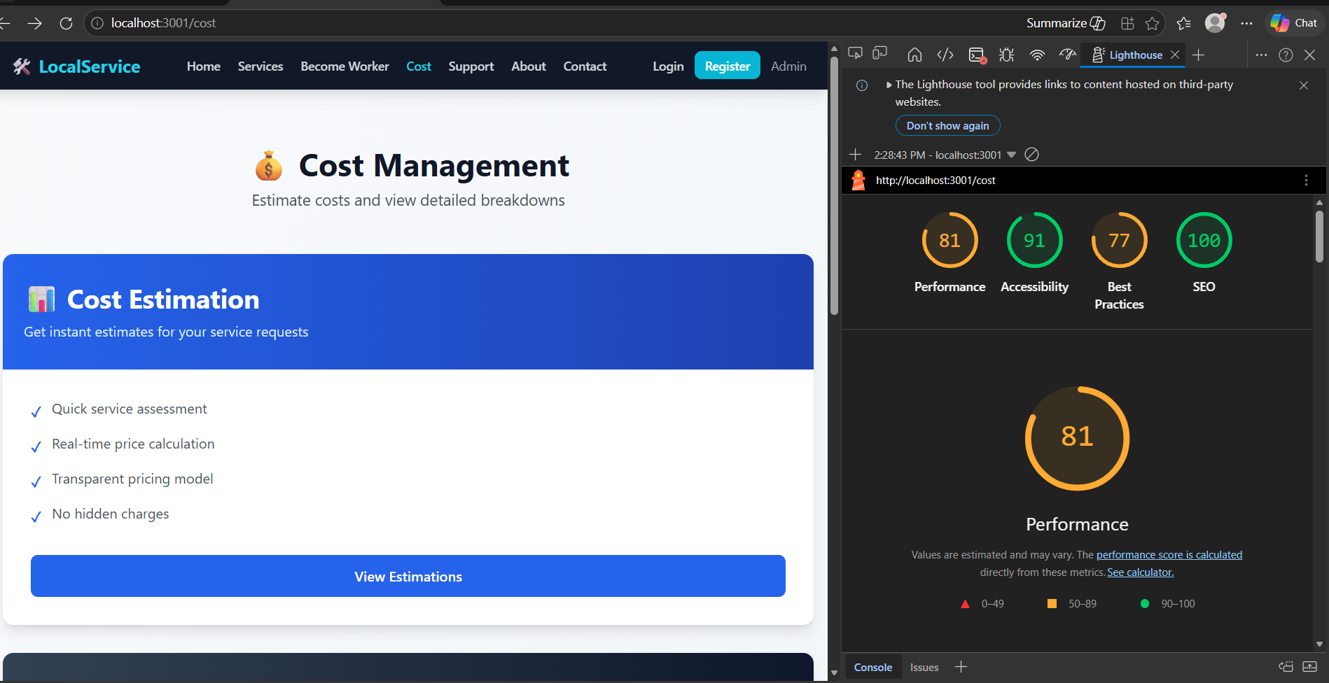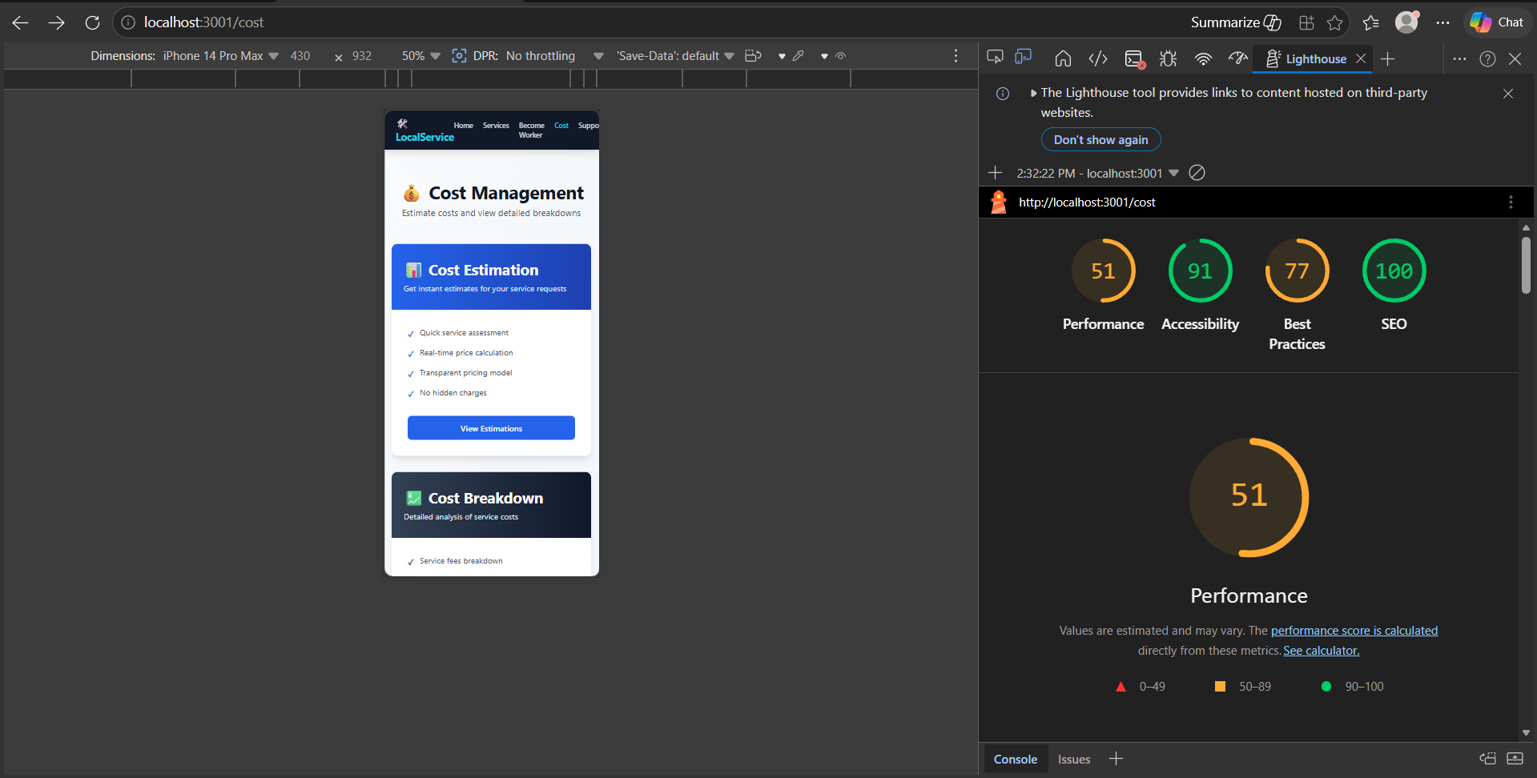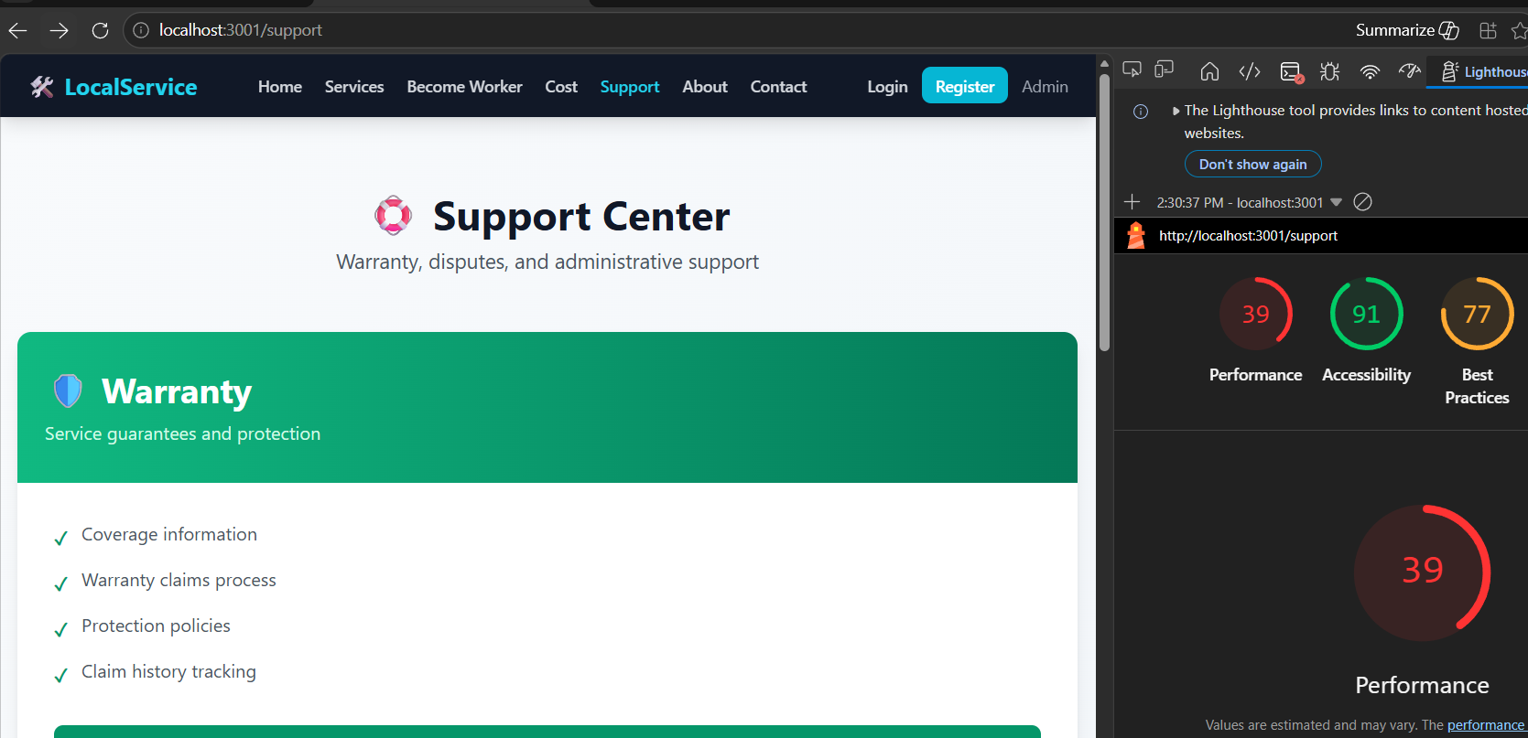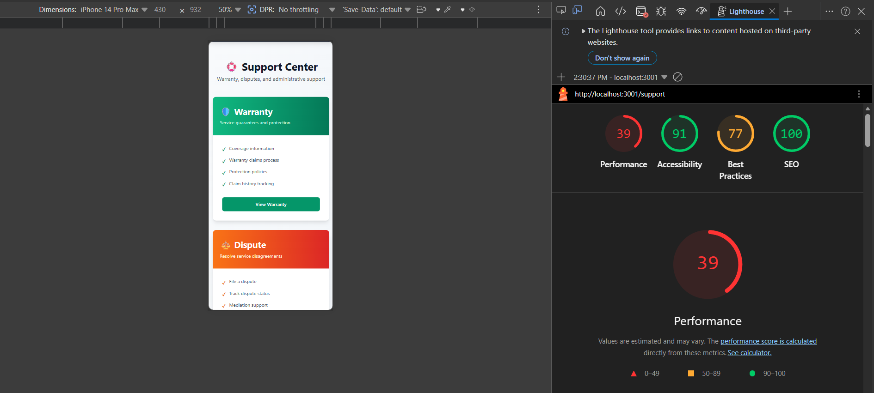

FARHAN :
- Performance and Network analysis of Post Job as a customer. Pc view and phone view analysis given sequentially:
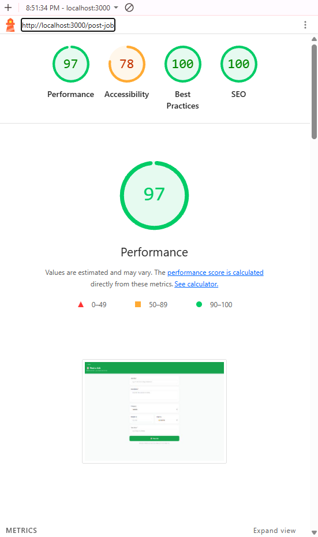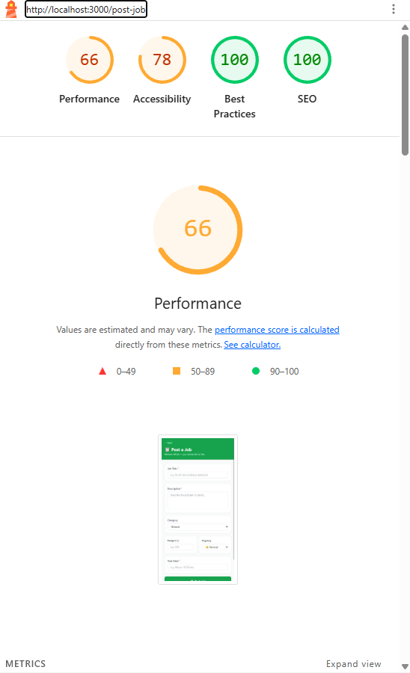

- Performance and Network analysis of Browse workers as customer. Pc view and phone view analysis given sequentially:
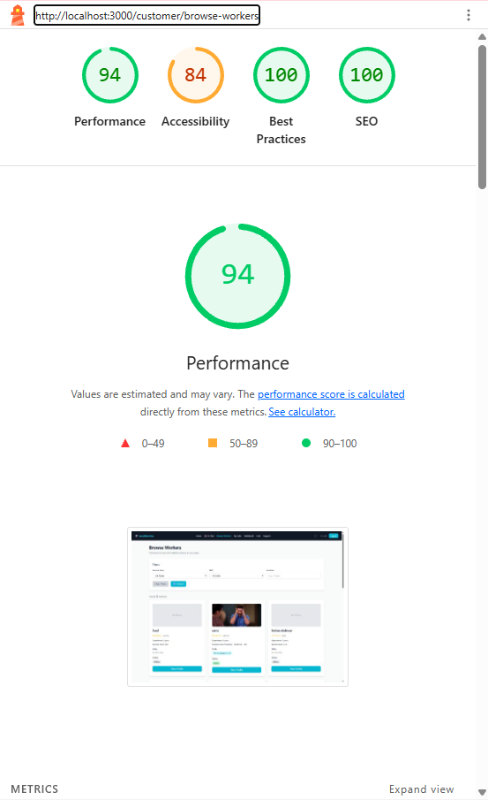
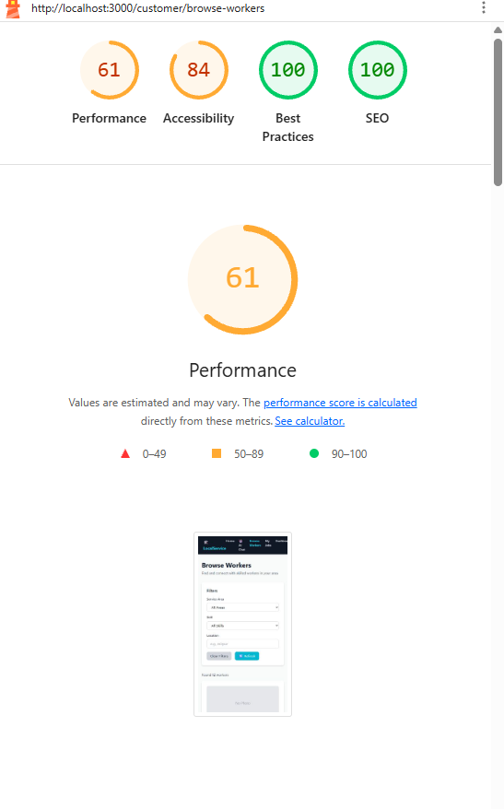
Saud
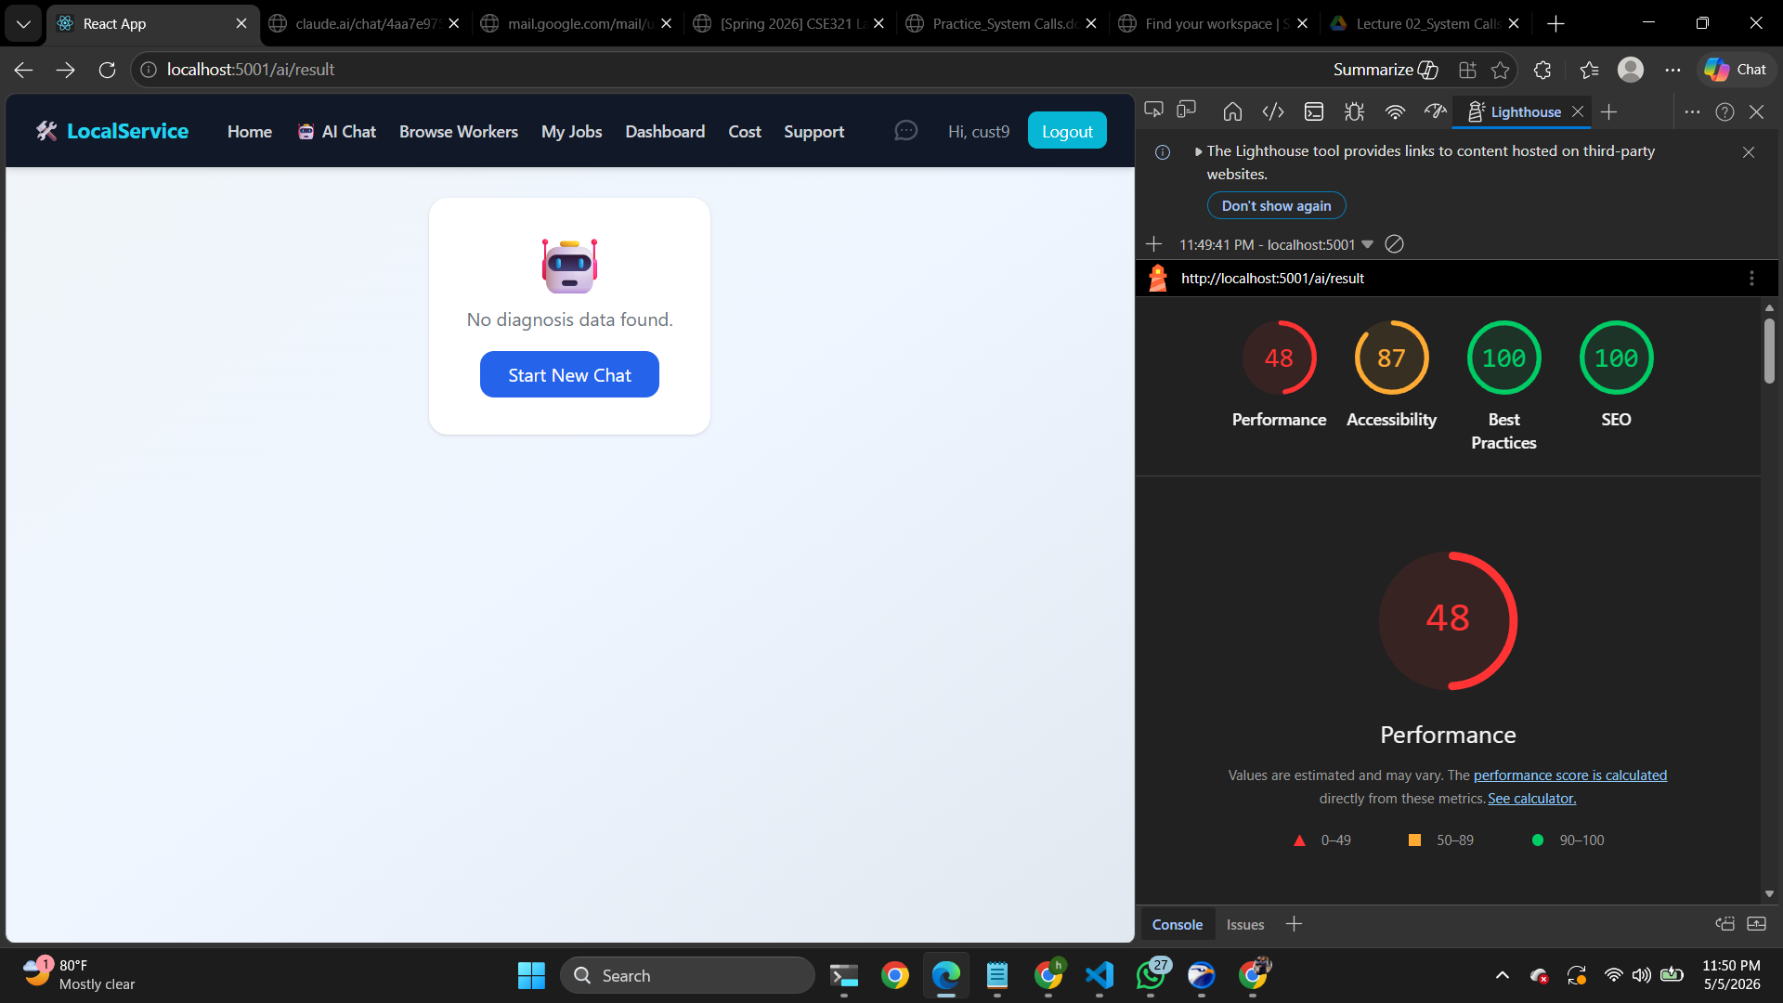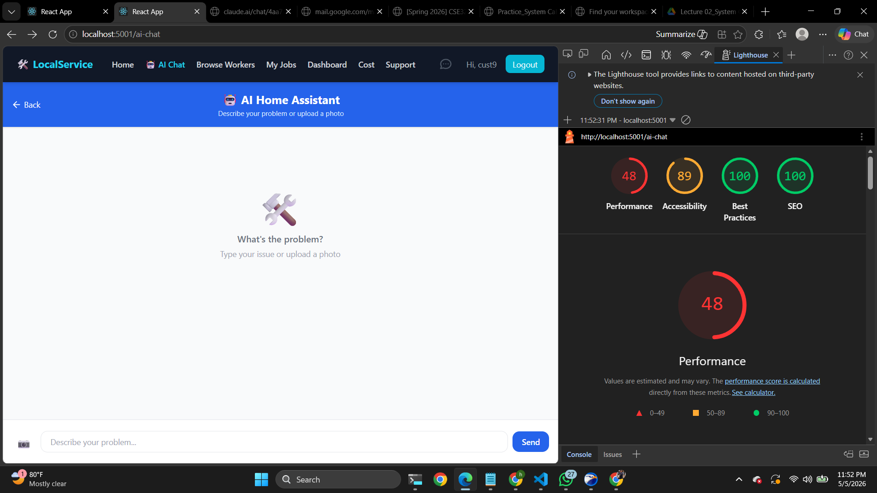
3
9. Github Repo [Public] Link

https://github.com/SaucySalamander1/smart-local-service-intelligence-platform
10. Link of Deployed Project
https://vercel.com/SaucySalamander1/smart-local-service-intelligence-platform (need assistance )
11. Individual Contribution
Group member - 01
Name: Deema Tabassum Khan | Student ID:23101162
Functional Requirements which are developed by this member:
1.The system provides an estimated service cost before booking based on service type, labor, parts, and urgency level.
2.The system displays a transparent cost breakdown including labor cost, parts cost, and urgency charges to ensure pricing clarity.
3.The system allows users to view detailed cost information before confirming a booking decision.
4.The system maintains a history of disputes and resolutions for future reference and transparency.
5.The system tracks service warranty information for completed jobs, including warranty duration, start date, and expiry date.
6.The system displays warranty coverage details such as labor, parts, and additional service conditions.
7.The system allows users to submit disputes related to pricing or service quality with detailed descriptions.
8.The system supports file upload functionality, enabling users to attach supporting documents or images when submitting disputes.
9.The system provides a dispute management workflow where administrators can review, update, and resolve disputes.
10.The system allows users to track the real-time status of submitted disputes (e.g., Submitted, In Review, Resolved).
11.The system enables administrators to update dispute status and provide resolution details including compensation or notes.

Group member - 02
Name: Farhan Shahriar | Student ID:23101214
Functional Requirements which are developed by this member:
1.The system allows users to create and manage their profile, including editing personal information such as name, email, and password.
2.The system enables users to browse available workers based on skills, ratings, experience, and service area.
3.The system allows users to post service requests or jobs by providing necessary details such as service type, location, and urgency level.
4.The system maintains and displays worker profiles including skill details, ratings, experience, and service area.
5.The system allows workers to update their real-time availability status, indicating whether they are available for new jobs.
6.The system ranks workers using a rating-based ranking algorithm to help users select the best service provider.
7.The system allows users to send service requests directly to workers and supports an emergency priority request option for urgent service needs.
8.The system allows both customers and workers to view and manage their job history, including ongoing and completed jobs.
9.The system enables users to rate and review workers after service completion, contributing to the overall rating system.
10.The system filters workers based on the user’s location to provide relevant and nearby service options.
11.The system supports messaging functionality, allowing communication between users and workers.

Group member - 03
Name: Shees Mohammad Hossain Saud | Student ID:20101234
Functional Requirements which are developed by this member:
1.The system allows users to submit issues using natural language text input.
2.The system automatically categorizes issues into predefined categories such as Electrical, Plumbing, and AC-related problems.
3.The system provides a guided troubleshooting flow using a step-by-step decision-making process.
4.The system evaluates and displays a risk level indicator (Low / Medium / High) before suggesting any DIY action.
5.The system analyzes the submitted issue based on category, complexity, and risk level to determine whether it is suitable for DIY resolution.
6.The system generates an intelligent recommendation indicating whether the user should proceed with DIY troubleshooting or seek professional assistance.
7.The system calculates and displays a confidence score (%) representing the likelihood of successful DIY resolution.
8.The system maintains a record of all user-submitted issues, including problem description, issue category, suggested troubleshooting steps, risk level, and final outcome.
9.The system stores troubleshooting history to improve future recommendations and provide users access to past issue resolutions.
10.The system allows users to navigate quickly after ai results to resolve the issue

12. References

Technical Documentation and Resources:
1. React.js Official Documentation - https://react.dev
2. Express.js Framework Guide - https://expressjs.com
3. MongoDB Developer Documentation - https://docs.mongodb.com
4. Node.js Official Documentation - https://nodejs.org/docs/
5. Socket.io Real-time Communication - https://socket.io/docs/
6. JWT Authentication Guide - https://jwt.io/
7. Groq API Documentation - https://console.groq.com/docs/
8. Multer File Upload Handling - https://github.com/expressjs/multer
9. Lighthouse Performance Auditing - https://developers.google.com/web/tools/lighthouse
10. Vercel Deployment Documentation - https://vercel.com/docs
Development Tools Used:
• Visual Studio Code - Code editor and development environment
• Postman - API testing and documentation platform
• Git & GitHub - Version control and repository management
•Figma - UI/UX design and prototyping
• MongoDB Compass - Database management and exploration

5

